Multiple-Point Intersection

Definition
# Source: AI Source: Provided by: [Data Path: Persons Table -> ID Column: 1, Name_En Column: Motasem Essam] -> From: [ChatGPT] on [7/25/2026]
Multiple-Point Intersection is a type of geometric intersection that occurs when two or more geometric objects share more than one common point.
Unlike a point intersection, which has exactly one common point, a multiple-point intersection contains two or more distinct common points.
Mathematically, if geometric objects $A$ and $B$ share several points:
$$\boxed{A∩B={\{P}_{1},P_{2},…,P_{n}\}}$$
where:
$$\boxed{n≥2}$$
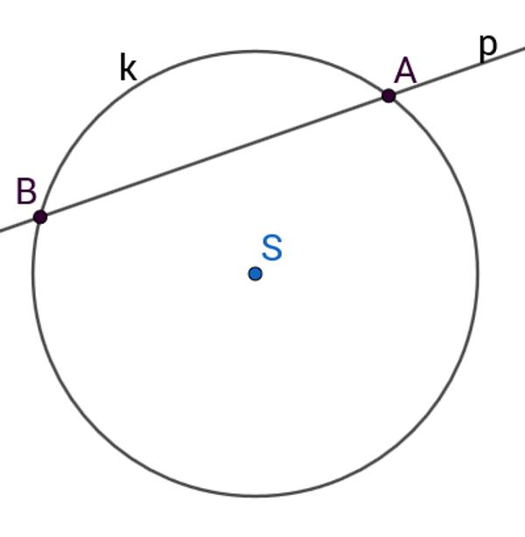
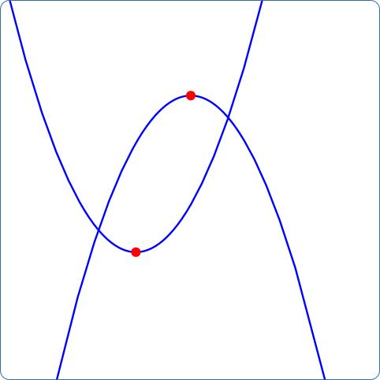
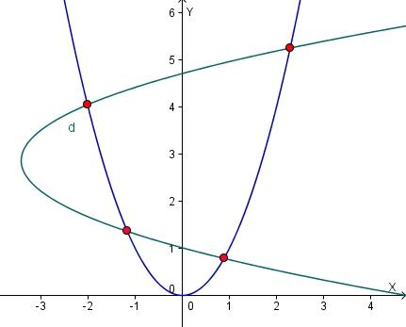
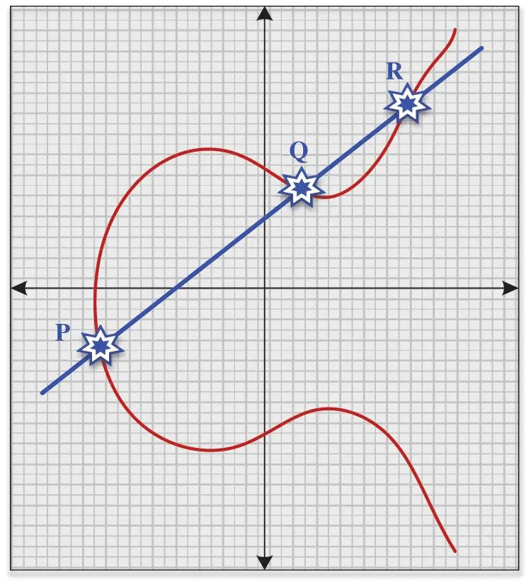
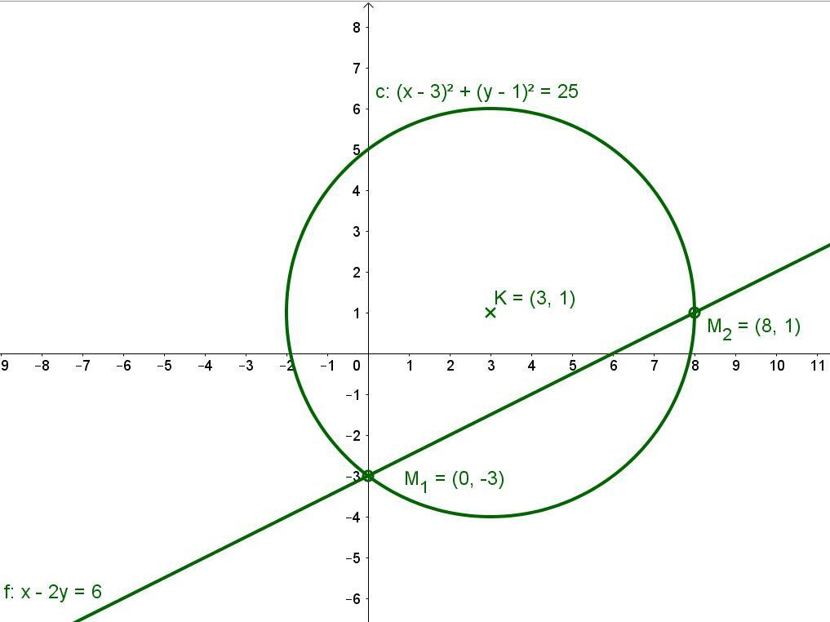

Purpose
# Source: AI Source: Provided by: [Data Path: Persons Table -> ID Column: 1, Name_En Column: Motasem Essam] -> From: [ChatGPT] on [7/25/2026]
Multiple-point intersection is used to:
- Identify several common points between geometric objects.
- Analyze intersections between lines and curves.
- Determine where circles or curves cross.
- Study geometric relationships.
- Solve systems of equations.
- Analyze polygons and complex shapes.
- Determine common boundaries or regions.
- Support CAD, engineering, surveying, GIS, and computer graphics.

Fundamental Idea
# Source: AI Source: Provided by: [Data Path: Persons Table -> ID Column: 1, Name_En Column: Motasem Essam] -> From: [ChatGPT] on [7/25/2026]
The fundamental idea is simple:
Two or more geometric objects have more than one common point.
For example, a line can intersect a circle at two points:
$$\boxed{l∩C=\{A,B\}}$$
Here, $A$ and $B$ are two distinct intersection points.
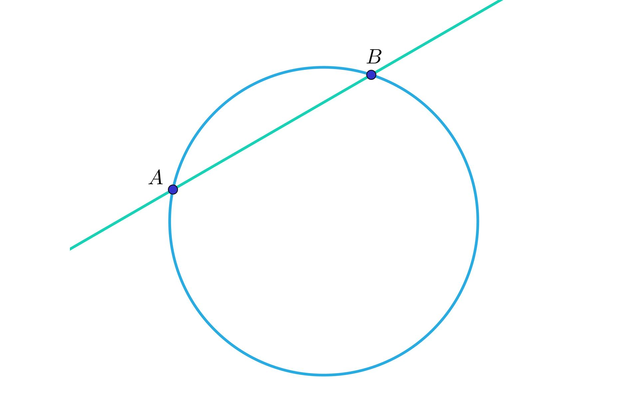
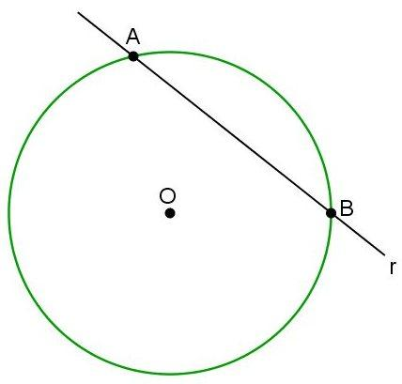
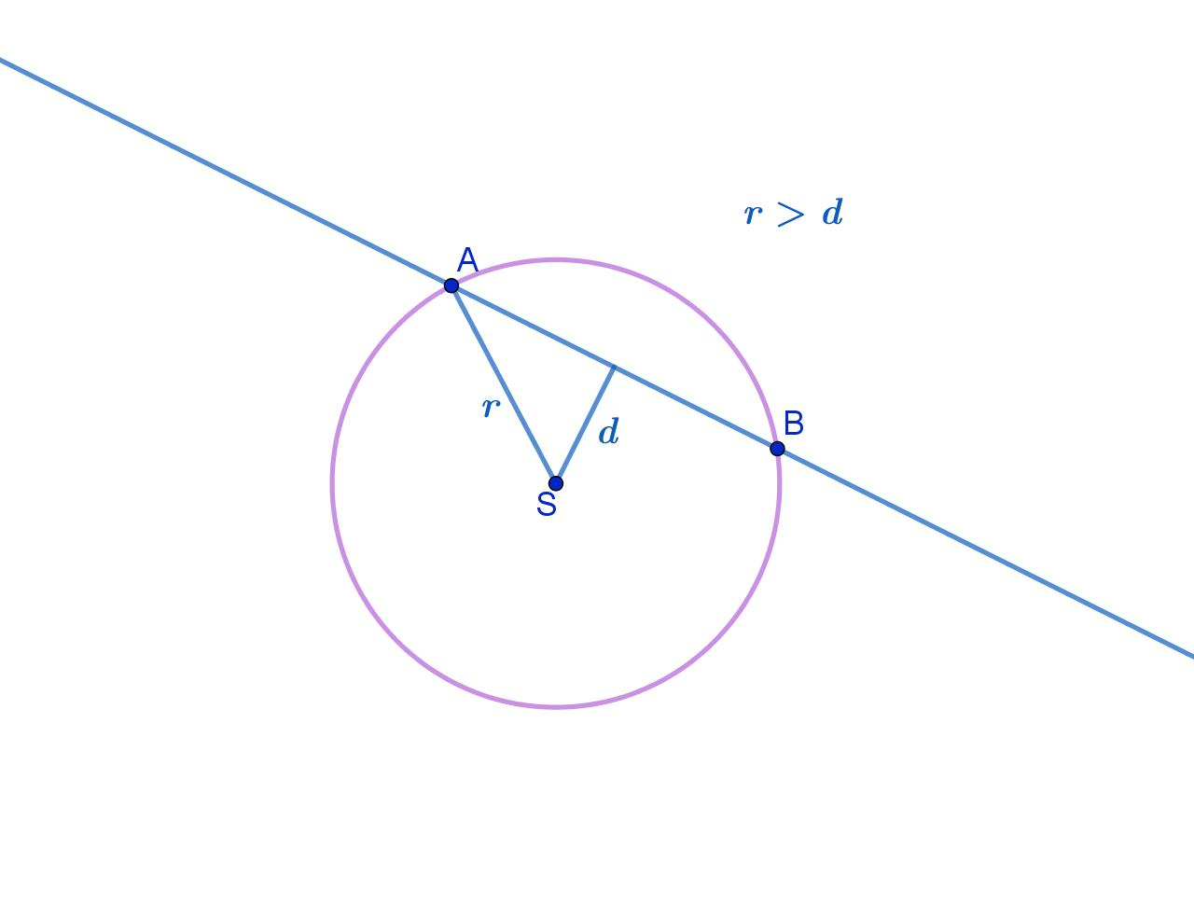
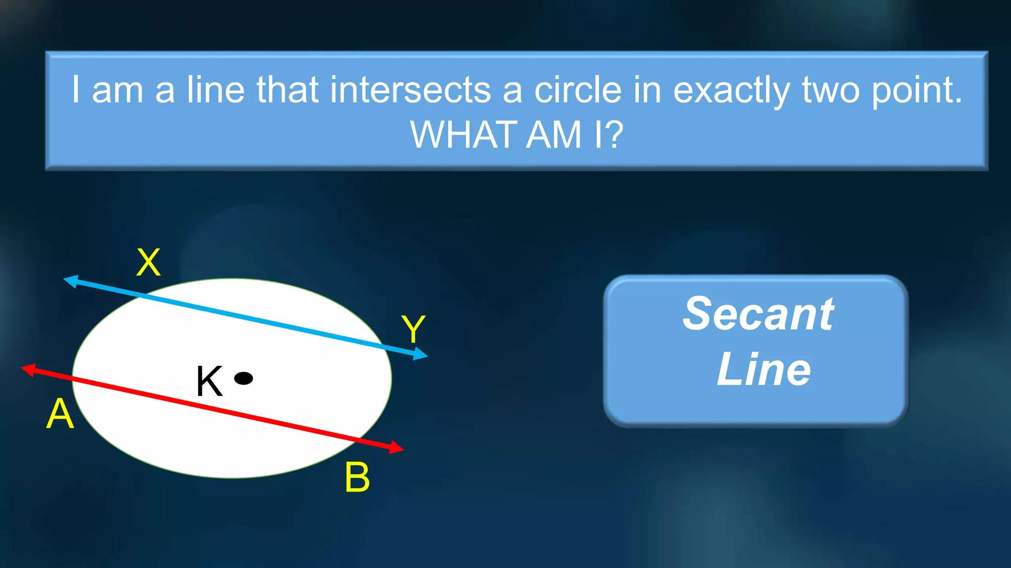

Mathematical Representation
# Source: AI Source: Provided by: [Data Path: Persons Table -> ID Column: 1, Name_En Column: Motasem Essam] -> From: [ChatGPT] on [7/25/2026]
If two geometric objects $A$ and $B$ have multiple common points:
$$\boxed{A∩B=\{P_{1},P_{2},…,P_{n}\}}$$
where $n$ represents the number of distinct intersection points.
For two points:
$$\boxed{A∩B={\{P}_{1},P_{2}\}}$$
For three points:
$$\boxed{A∩B={\{P}_{1},P_{2},P_{3}\}}$$

Two-Point Intersection
# Source: AI Source: Provided by: [Data Path: Persons Table -> ID Column: 1, Name_En Column: Motasem Essam] -> From: [ChatGPT] on [7/25/2026]
The most common example of multiple-point intersection is when two objects intersect at exactly two points.
For example, a line and a circle can intersect at:
$$\boxed{P_{1}}$$
and:
$$\boxed{P_{2}}$$
Therefore:
$$\boxed{l∩C=\{P_{1},P_{2}\}}$$
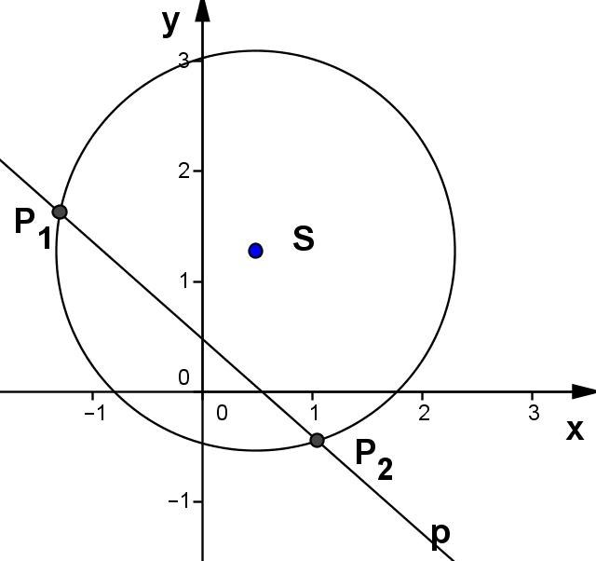
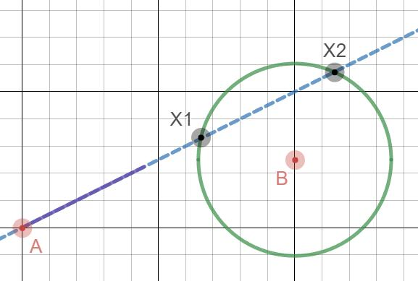
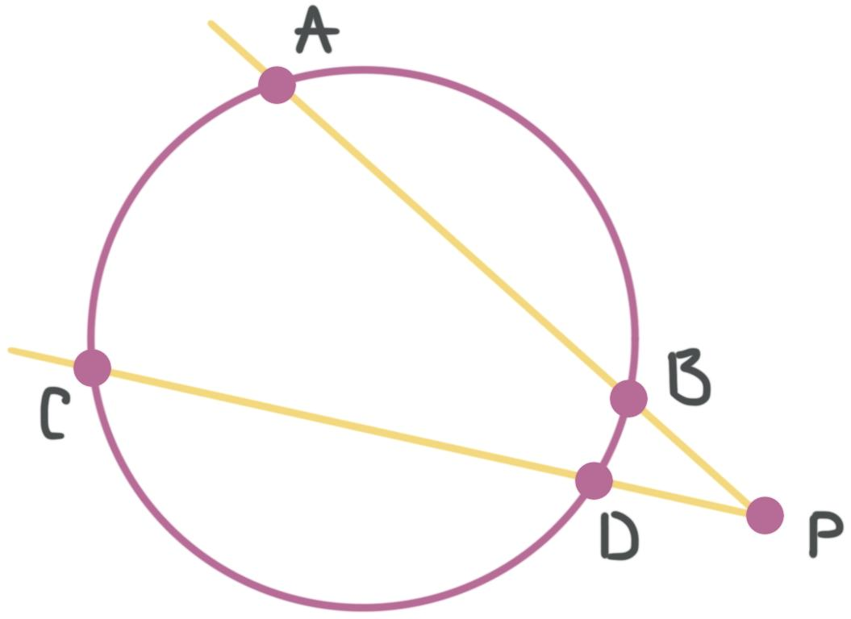
This type of line is called a secant line.

Secant Intersection
# Source: AI Source: Provided by: [Data Path: Persons Table -> ID Column: 1, Name_En Column: Motasem Essam] -> From: [ChatGPT] on [7/25/2026]
A secant is a line that intersects a circle at two distinct points.
If the intersection points are $A$ and $B$:
$$\boxed{l∩C=\{A,B\}}$$
The segment between $A$ and $B$ is a chord of the circle.
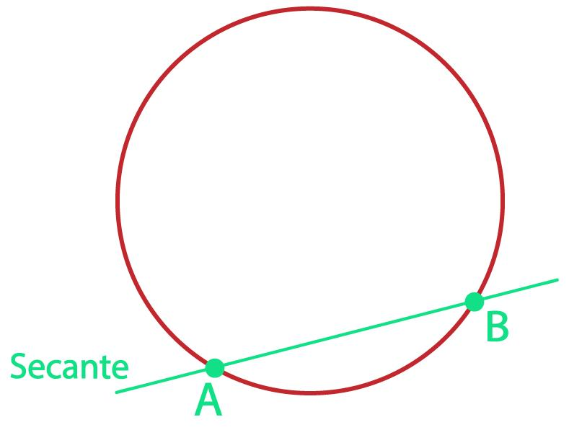
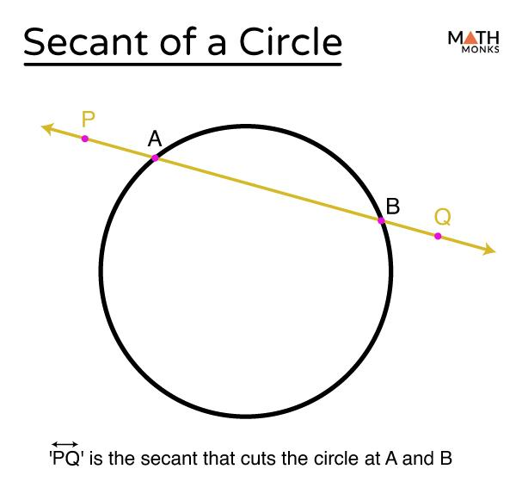
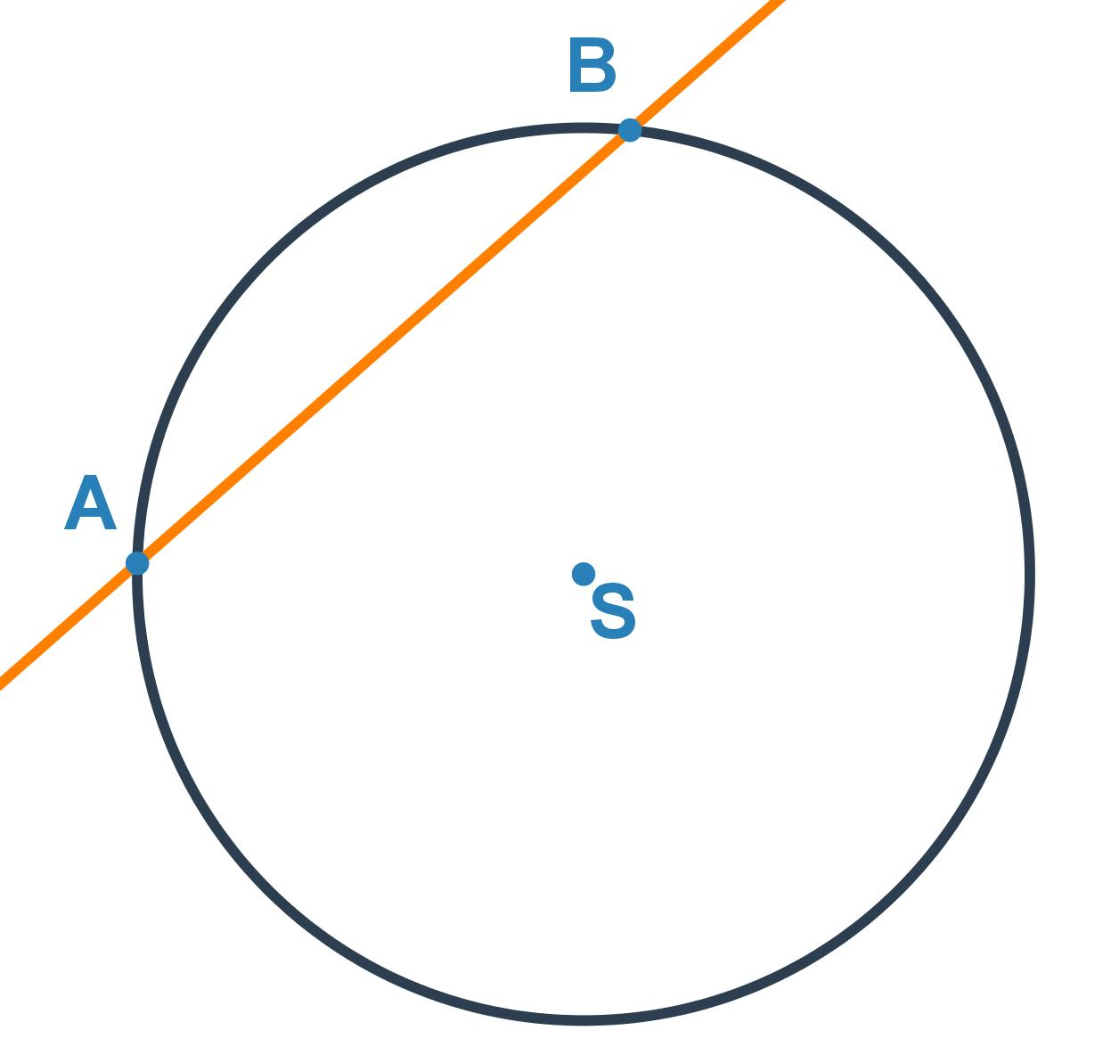

Multiple Intersection of Curves
# Source: AI Source: Provided by: [Data Path: Persons Table -> ID Column: 1, Name_En Column: Motasem Essam] -> From: [ChatGPT] on [7/25/2026]
Two curves can intersect at several distinct points.
For example:
$$C_{1}∩C_{2}={\{P}_{1},P_{2},P_{3}\}$$
if the curves share three distinct points.
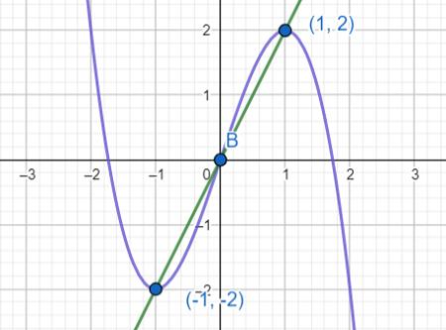
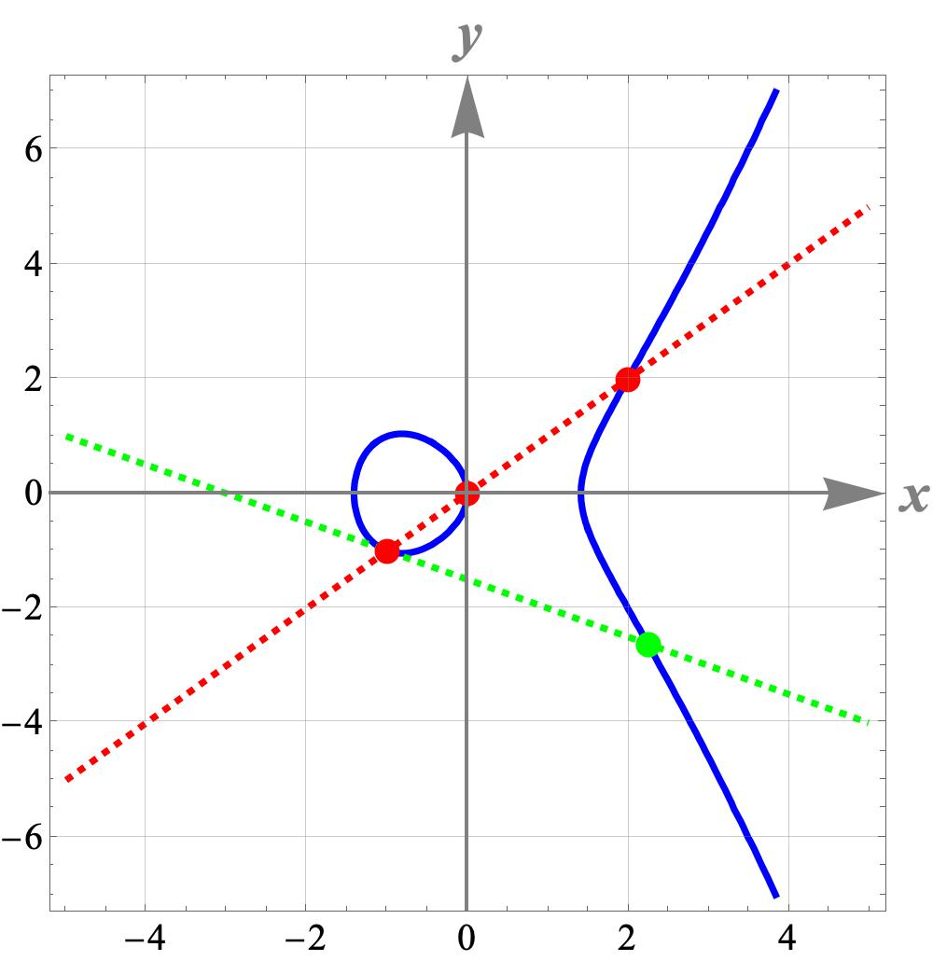
The number of possible intersections depends on the shapes and equations of the curves.

Intersection of Two Circles
# Source: AI Source: Provided by: [Data Path: Persons Table -> ID Column: 1, Name_En Column: Motasem Essam] -> From: [ChatGPT] on [7/25/2026]
Two circles can intersect at two distinct points.
If the points are $A$ and $B$:
$$\boxed{C_{1}∩C_{2}=\{A,B\}}$$
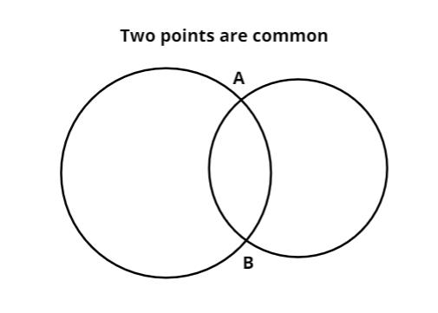
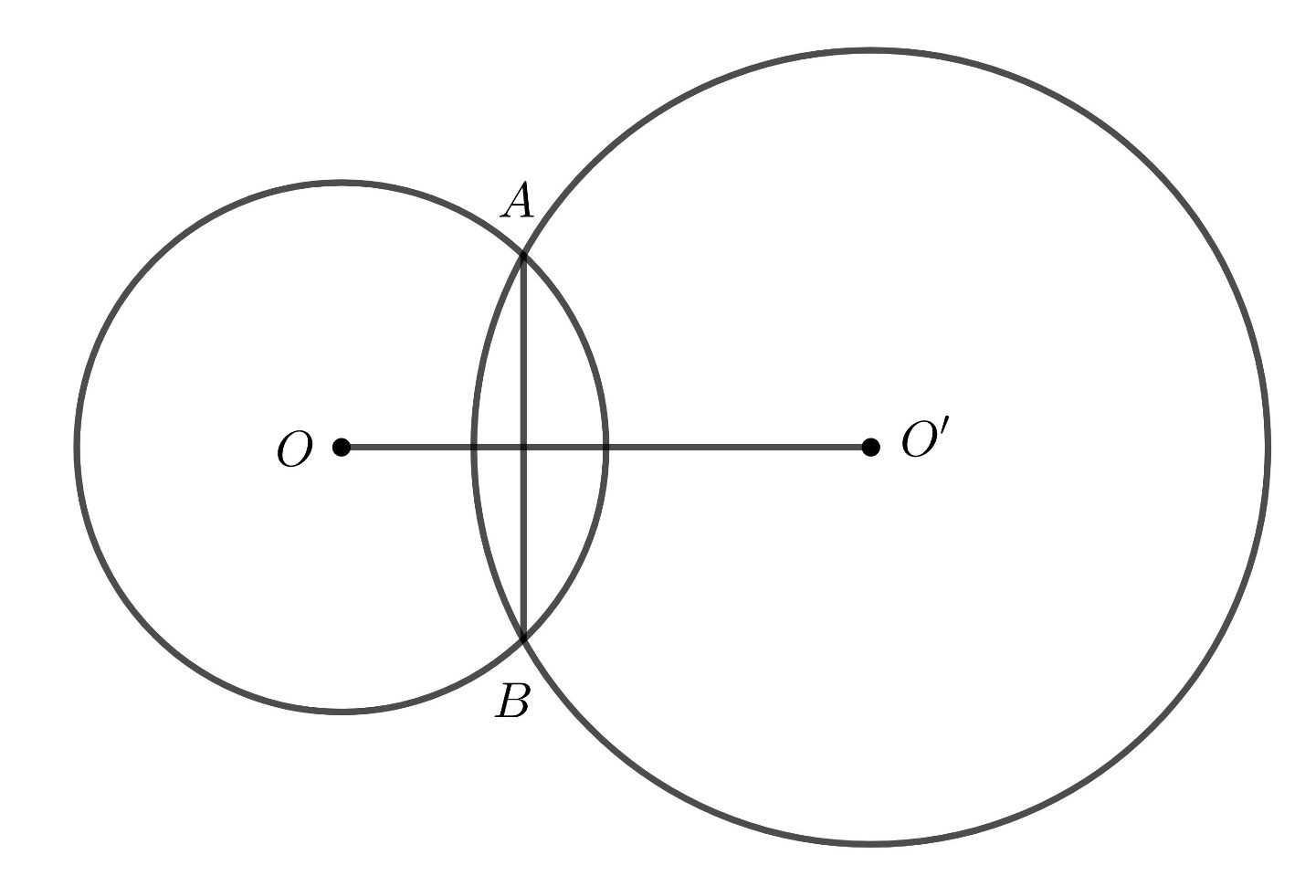
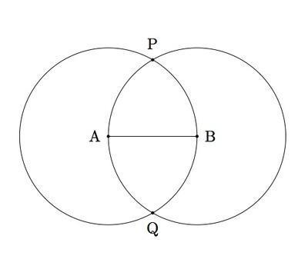
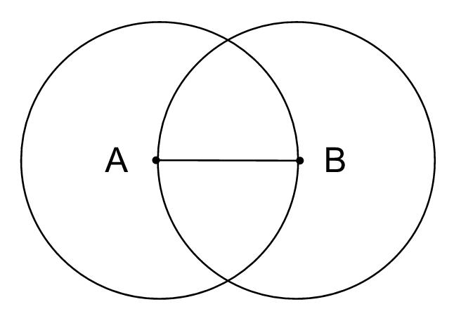
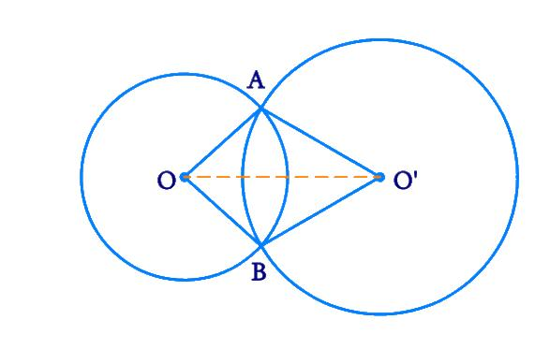
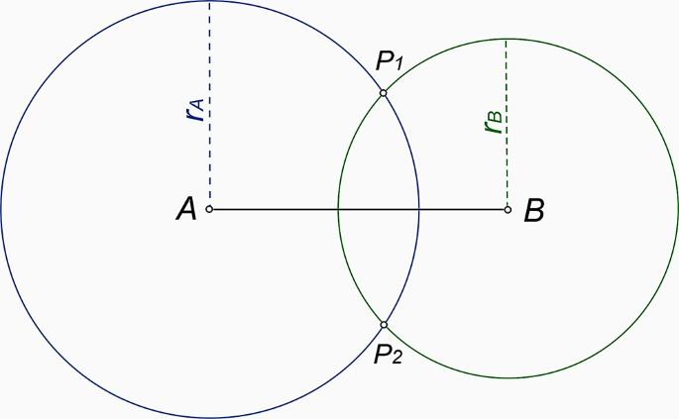
The two circles overlap in such a way that they cross each other at both points.

Circle–Circle Intersection Cases
# Source: AI Source: Provided by: [Data Path: Persons Table -> ID Column: 1, Name_En Column: Motasem Essam] -> From: [ChatGPT] on [7/25/2026]
Two circles can have different intersection relationships.
No Intersection
$$\boxed{C_{1}∩C_{2}=∅}$$
They have no common points.
One-Point Intersection
$$\boxed{C_{1}∩C_{2}=\{P\}}$$
The circles are tangent.
Two-Point Intersection
$$\boxed{C_{1}∩C_{2}={\{P}_{1},P_{2}\}}$$
The circles cross each other.
Coincident Circles
$$\boxed{C_{1}=C_{2}}$$
They share infinitely many points.
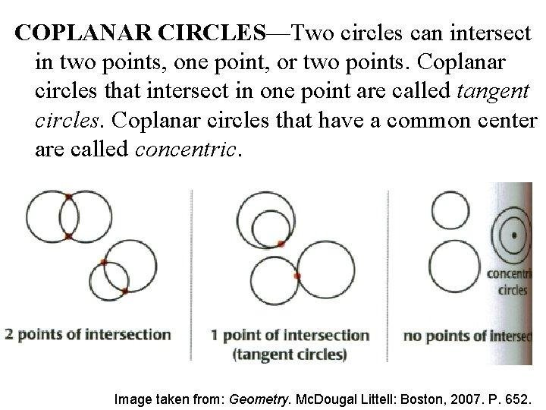
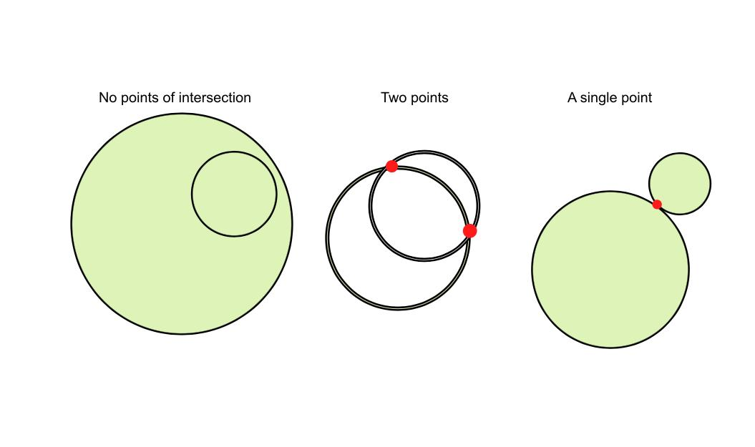
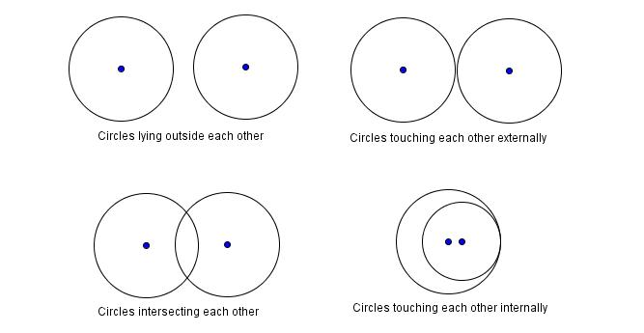

Multiple Intersections Between Polygons
# Source: AI Source: Provided by: [Data Path: Persons Table -> ID Column: 1, Name_En Column: Motasem Essam] -> From: [ChatGPT] on [7/25/2026]
Two polygons can intersect at several points.
For example, two polygons may cross each other at multiple locations.
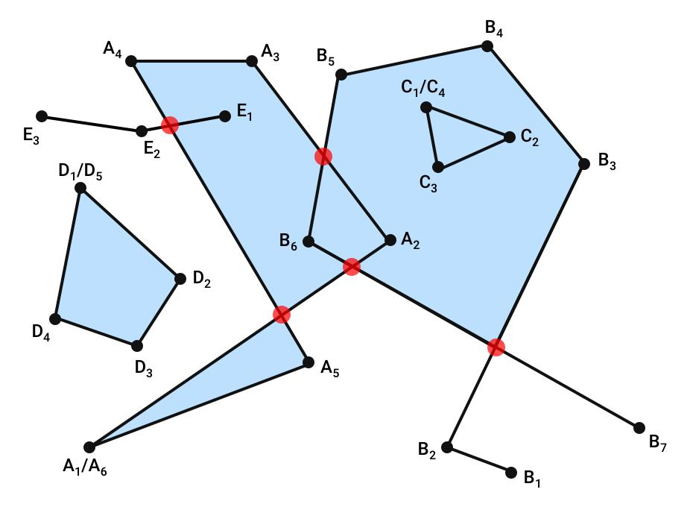
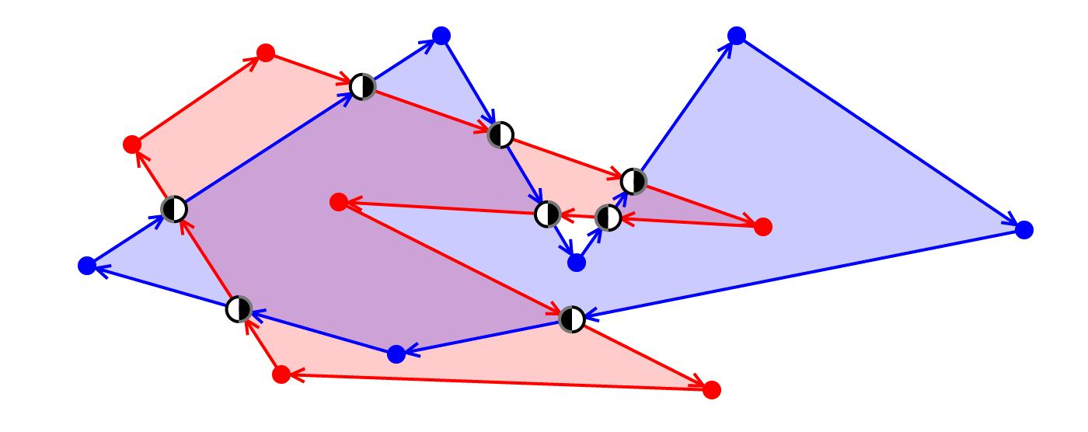
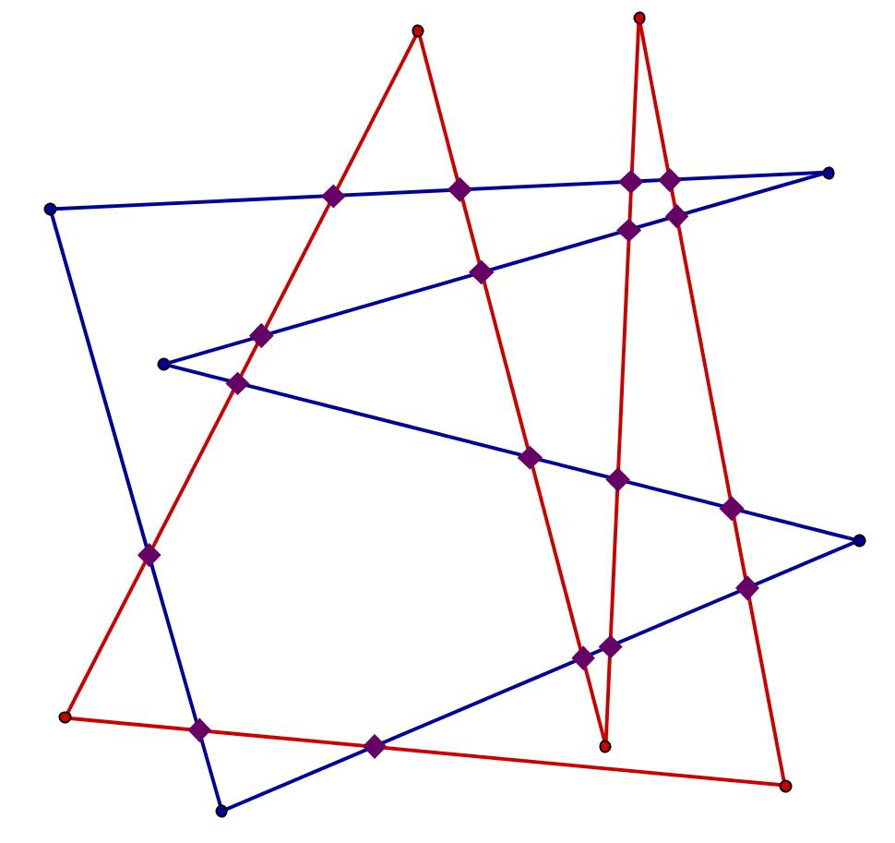
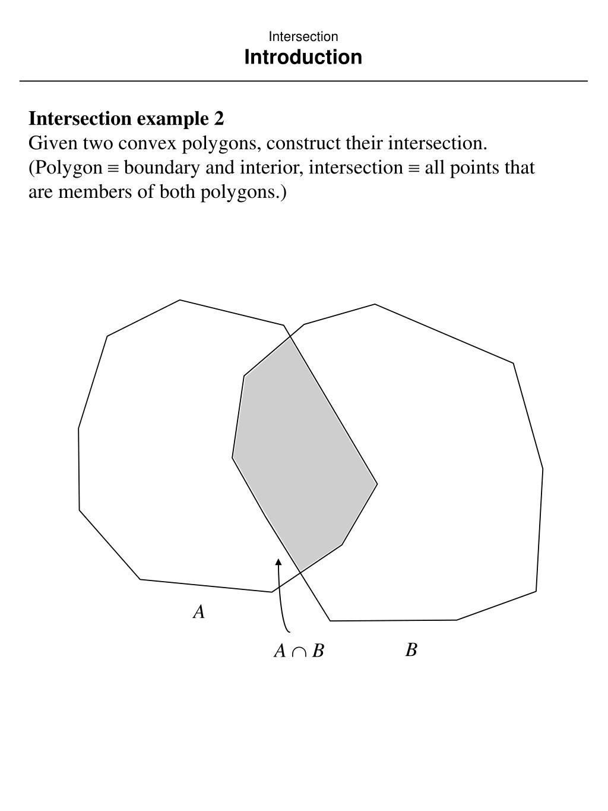
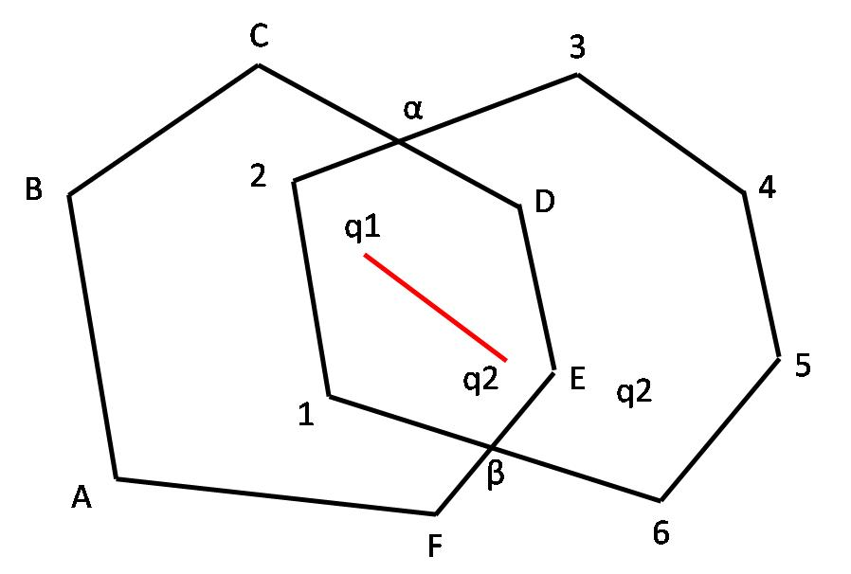
These intersection points can be used to:
- Divide the polygons into smaller regions.
- Determine overlapping areas.
- Create new vertices.
- Analyze boundaries.

Multiple Intersections of Line Segments
# Source: AI Source: Provided by: [Data Path: Persons Table -> ID Column: 1, Name_En Column: Motasem Essam] -> From: [ChatGPT] on [7/25/2026]
Although two individual straight line segments can have at most one intersection point unless they overlap, multiple line segments together can create many intersection points.
For example, several segments may cross at different locations:
$$P_{1},P_{2},P_{3},…$$
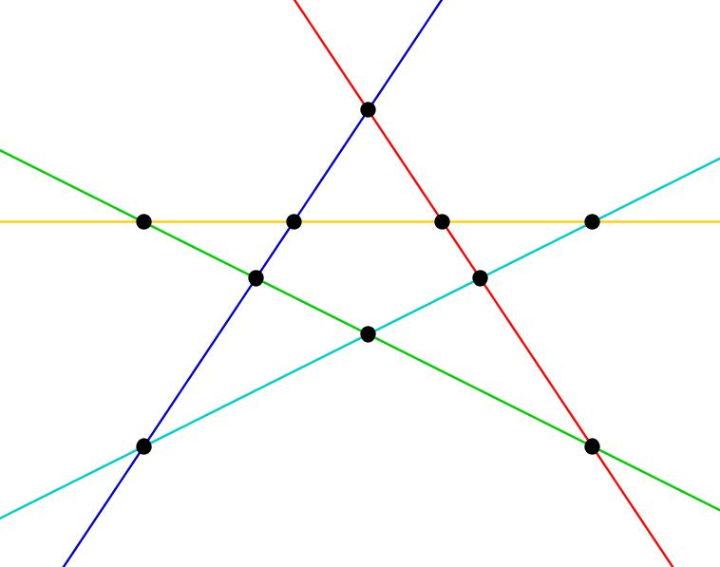
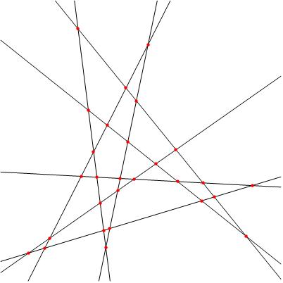
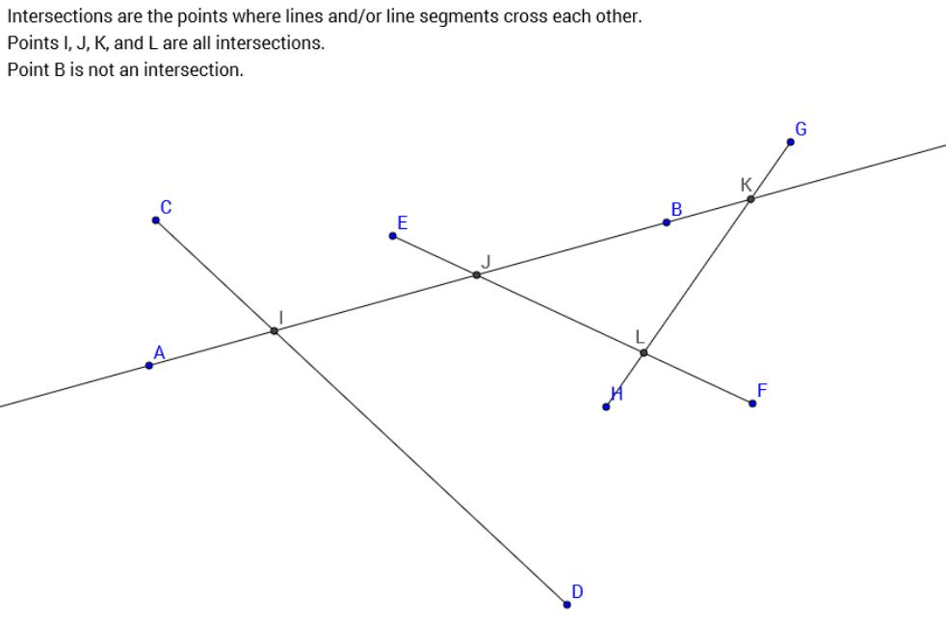
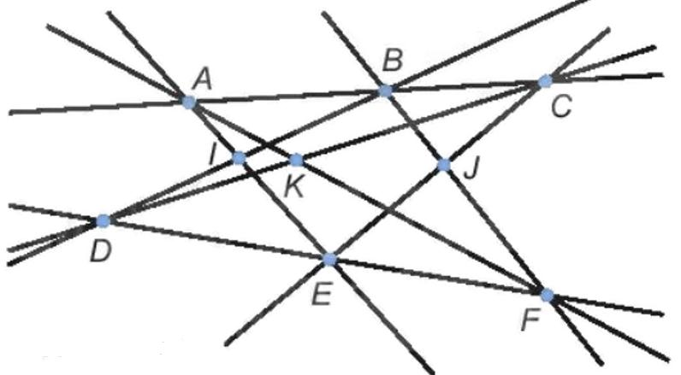
This is common in:
- Polygon networks.
- Geometric graphs.
- Road networks.
- Structural frameworks.
- CAD drawings.

Multiple Lines Meeting at One Point
# Source: AI Source: Provided by: [Data Path: Persons Table -> ID Column: 1, Name_En Column: Motasem Essam] -> From: [ChatGPT] on [7/25/2026]
There is an important distinction.
Several lines may pass through the same single point.
For example:
$$l_{1}∩l_{2}∩l_{3}=\{P\}$$
This is still a point intersection, because there is only one common point shared by all three lines.
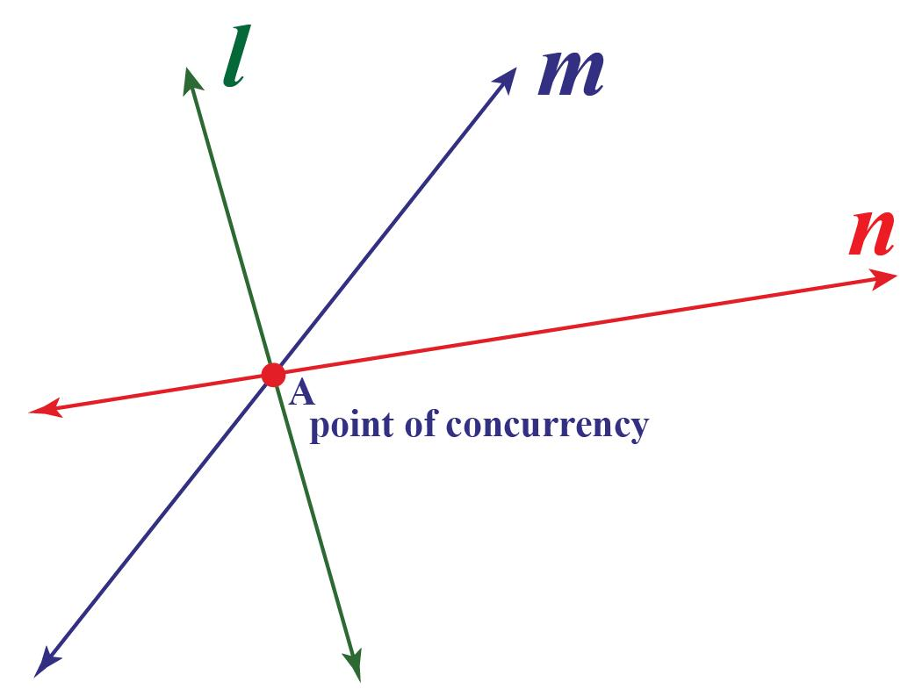
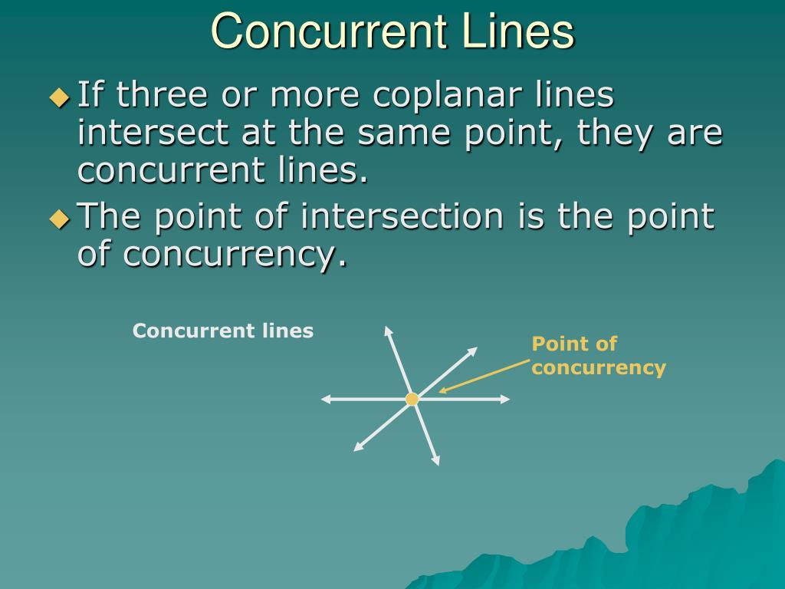
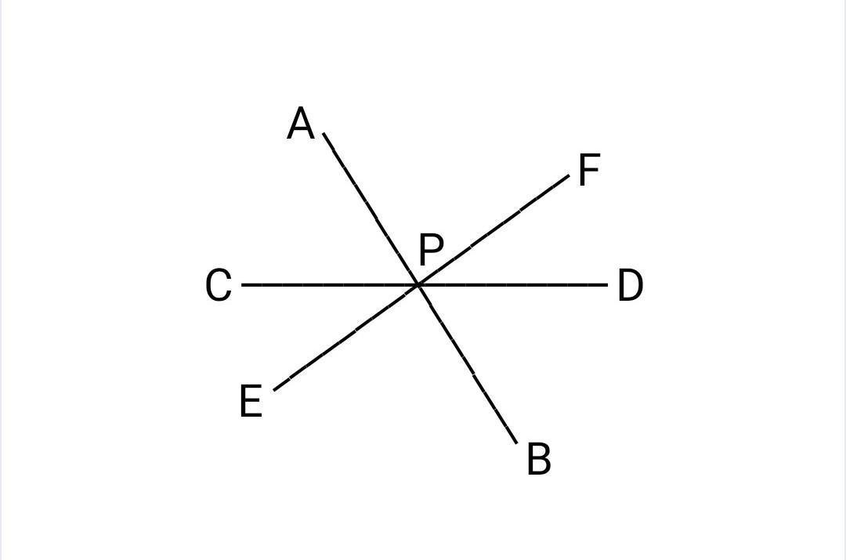
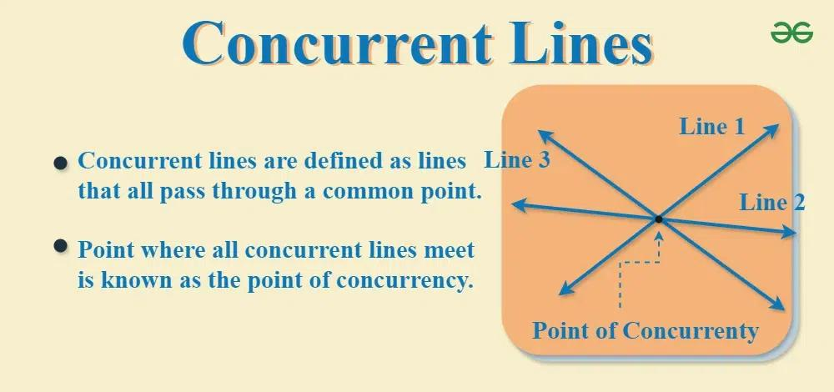
Therefore, the phrase multiple-point intersection means multiple distinct common points, not simply multiple objects meeting at one point.

Multiple-Point Intersection vs. Point Intersection
# Source: AI Source: Provided by: [Data Path: Persons Table -> ID Column: 1, Name_En Column: Motasem Essam] -> From: [ChatGPT] on [7/25/2026]
Point Intersection
Exactly one common point:
$$\boxed{A∩B=\{P\}}$$
Multiple-Point Intersection
More than one common point:
$$\boxed{A∩B={\{P}_{1},P_{2},…\}}$$
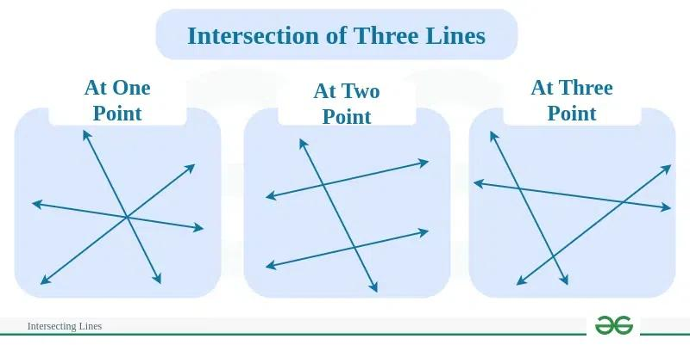
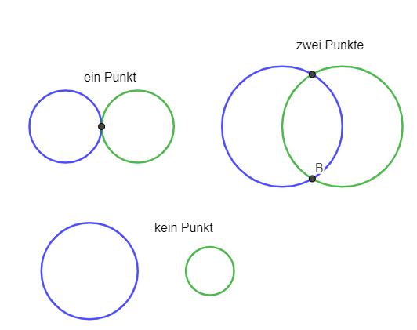

Multiple-Point Intersection vs. Coincidence
# Source: AI Source: Provided by: [Data Path: Persons Table -> ID Column: 1, Name_En Column: Motasem Essam] -> From: [ChatGPT] on [7/25/2026]
These concepts should also be distinguished.
Multiple-Point Intersection
There are several distinct but limited common points:
$$\boxed{A∩B={\{P}_{1},P_{2},…,P_{n}\}}$$
Coincidence
The objects overlap completely and have infinitely many common points:
$$\boxed{A∩B=A}$$
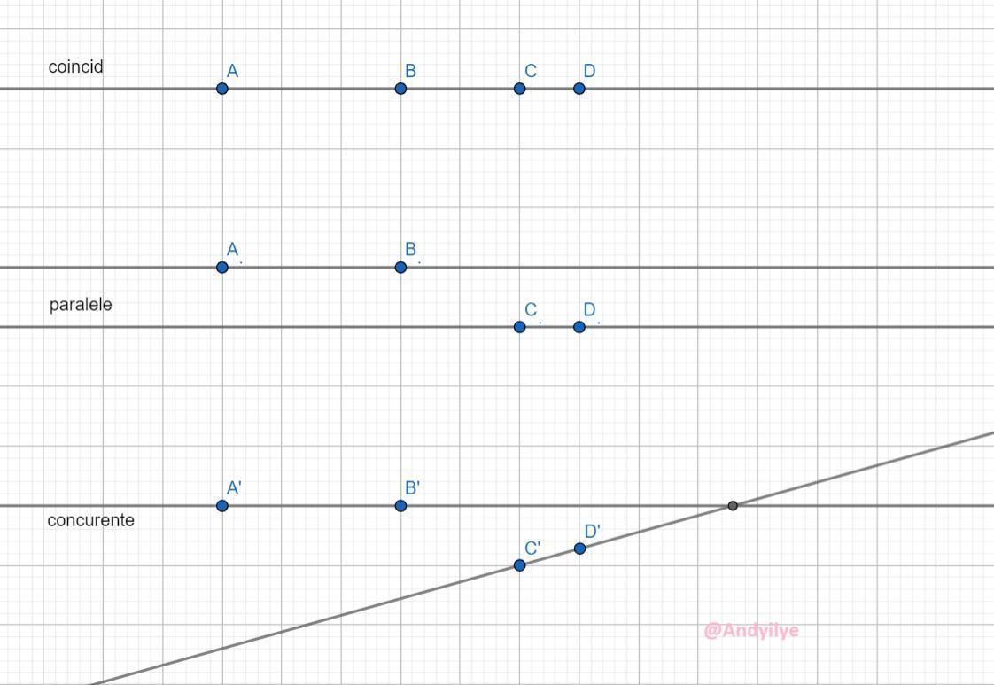
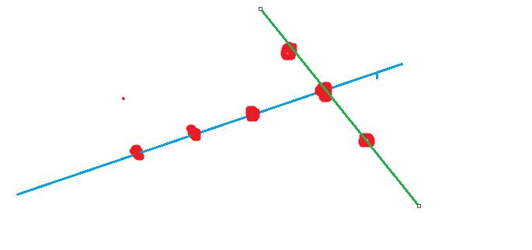

Line and Circle
# Source: AI Source: Provided by: [Data Path: Persons Table -> ID Column: 1, Name_En Column: Motasem Essam] -> From: [ChatGPT] on [7/25/2026]
A line and a circle provide one of the clearest examples.
No Intersection
The line is outside the circle:
$$\boxed{0\text{ points}}$$
Point Intersection
The line is tangent:
$$\boxed{1\text{ point}}$$
Multiple-Point Intersection
The line is secant:
$$\boxed{2\text{ points}}$$
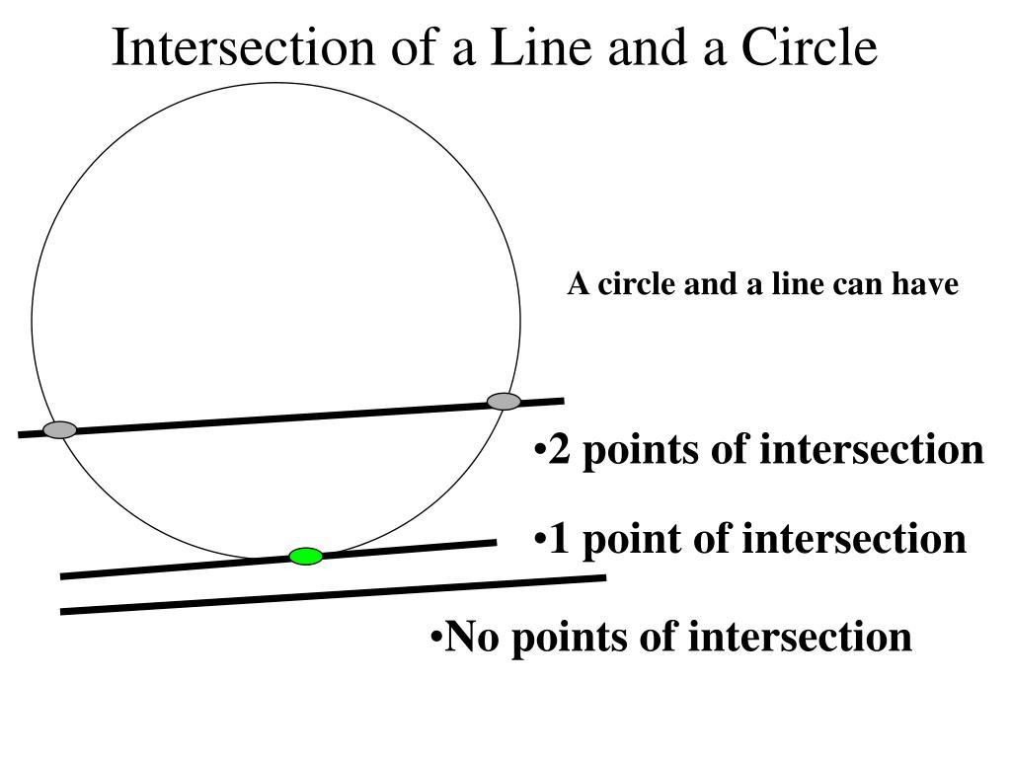
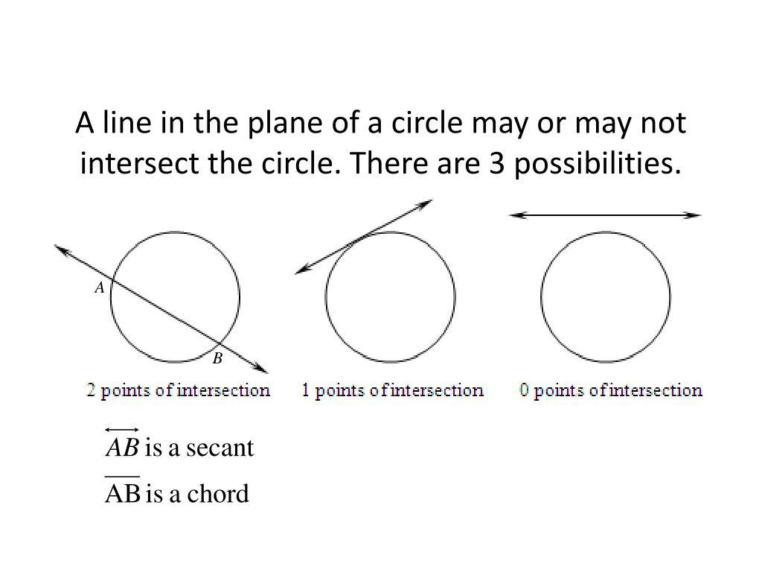
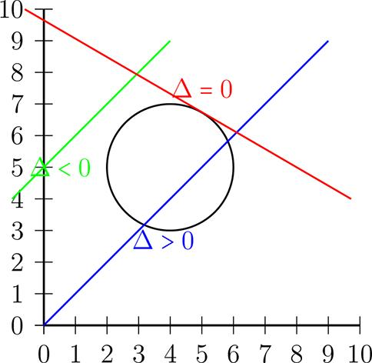

Multiple-Point Intersection in Coordinate Geometry
# Source: AI Source: Provided by: [Data Path: Persons Table -> ID Column: 1, Name_En Column: Motasem Essam] -> From: [ChatGPT] on [7/25/2026]
In coordinate geometry, multiple intersections can be found by solving equations simultaneously.
For example, consider:
$$y=x^{2}$$
and:
$$y=4$$
Set them equal:
$$x^{2}=4$$
Therefore:
$$x=±2$$
The corresponding points are:
$$\boxed{P_{1}=\left(-2,4\right)}$$
and:
$$\boxed{P_{2}=\left(2,4\right)}$$
Thus:
$$\boxed{\left(-2,4\right),\left(2,4\right)}$$
is the intersection of the parabola and the horizontal line.
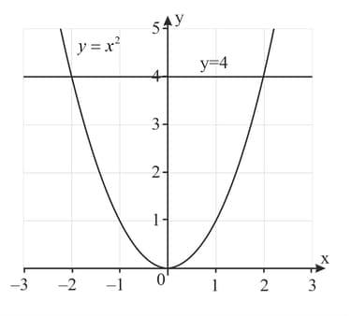
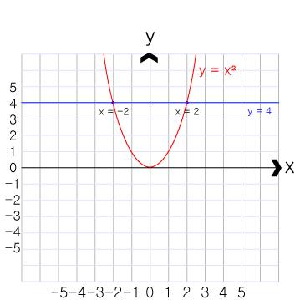
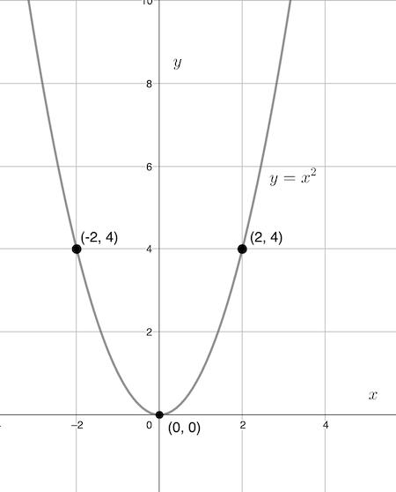
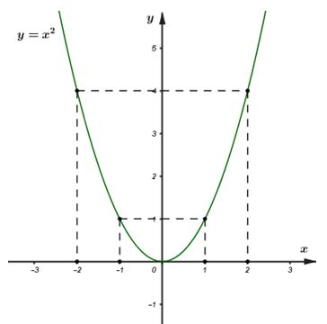
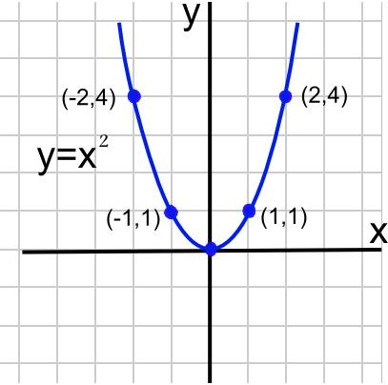

Algebraic Interpretation
# Source: AI Source: Provided by: [Data Path: Persons Table -> ID Column: 1, Name_En Column: Motasem Essam] -> From: [ChatGPT] on [7/25/2026]
Multiple-point intersection often corresponds to multiple solutions of a system of equations.
For example:
$$f\left(x\right)=g\left(x\right)$$
may produce:
$$x=x_{1},x_{2},…,x_{n}$$
Each valid solution corresponds to an intersection point.
Thus:
$$\boxed{\text{Multiple solutions}⟷\text{Multiple intersection points}}$$

Multiple Intersection and Curves
# Source: AI Source: Provided by: [Data Path: Persons Table -> ID Column: 1, Name_En Column: Motasem Essam] -> From: [ChatGPT] on [7/25/2026]
Curves can intersect several times.
For example, two complex curves might have:
$$P_{1},P_{2},P_{3},P_{4}$$
as common points.
Then:
$$\boxed{C_{1}∩C_{2}=\{P_{1},P_{2},P_{3},P_{4}\}}$$
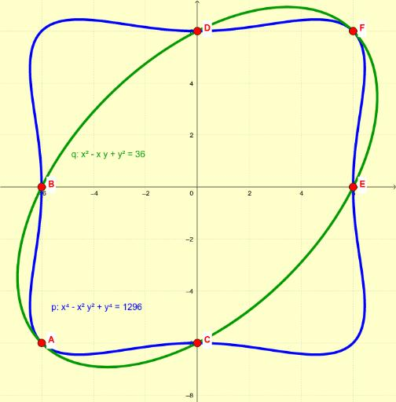
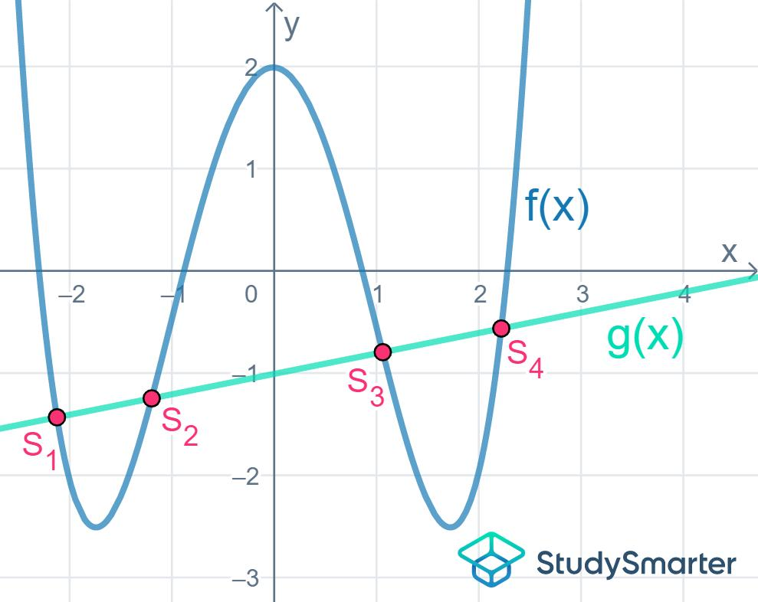
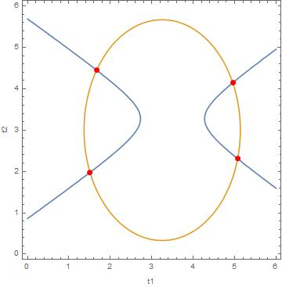
The exact maximum number of intersections depends on the types and degrees of the curves.

Multiple-Point Intersection in Polygons
# Source: AI Source: Provided by: [Data Path: Persons Table -> ID Column: 1, Name_En Column: Motasem Essam] -> From: [ChatGPT] on [7/25/2026]
When several polygon edges or diagonals are present, many intersection points can occur.
For example, diagonals in a complex polygon may cross each other at multiple locations.
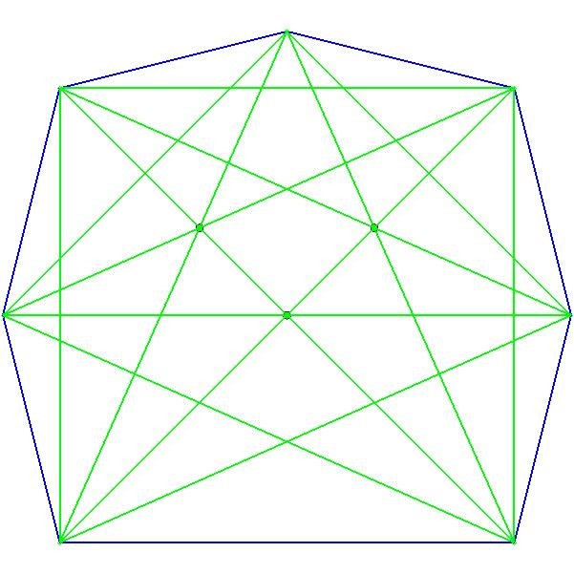
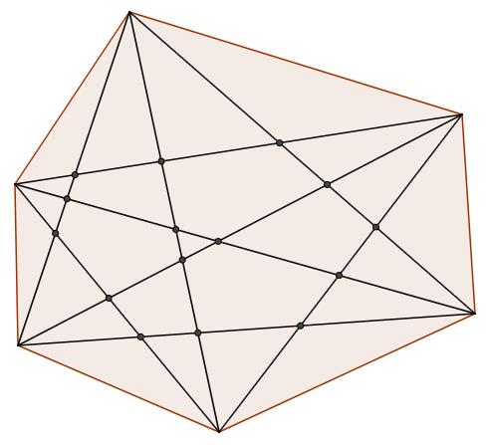
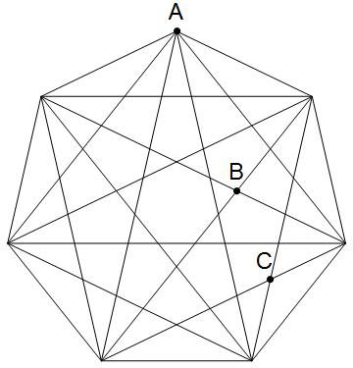
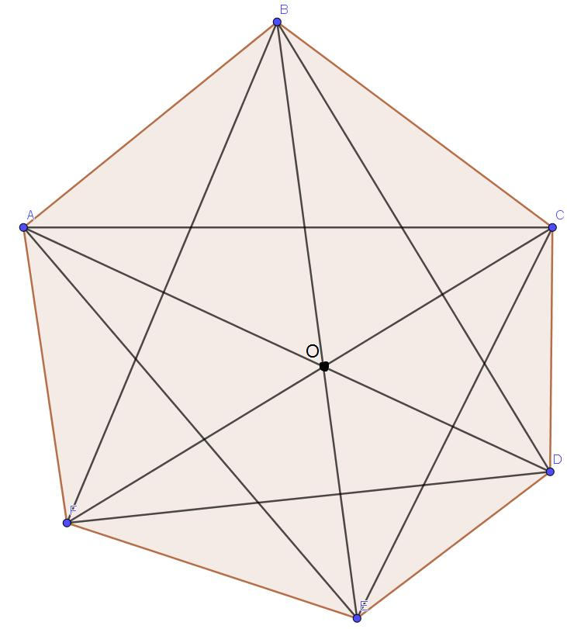
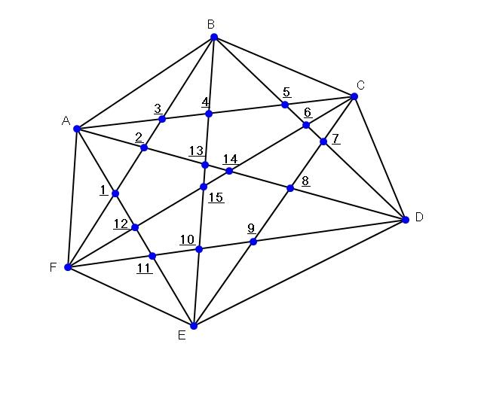
These intersections can divide the polygon into smaller regions.

Multiple-Point Intersection and Area
# Source: AI Source: Provided by: [Data Path: Persons Table -> ID Column: 1, Name_En Column: Motasem Essam] -> From: [ChatGPT] on [7/25/2026]
Multiple intersections are useful when determining the overlapping region of geometric objects.
For example, two shapes can cross at two or more boundary points, creating a common region.
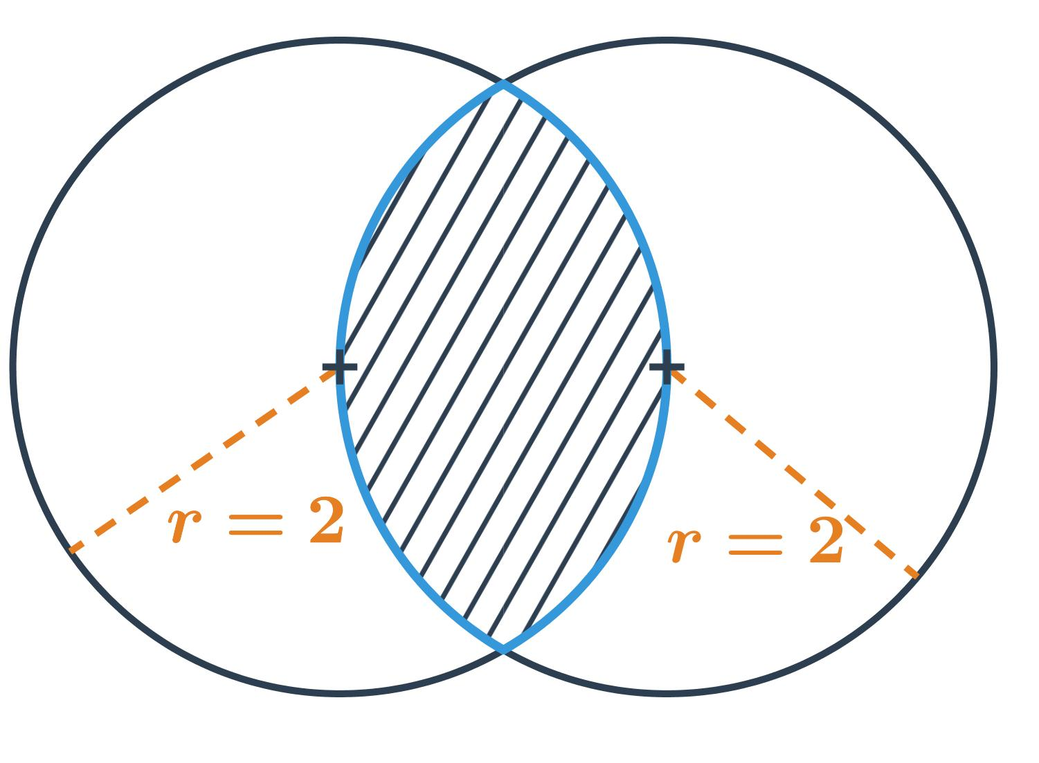
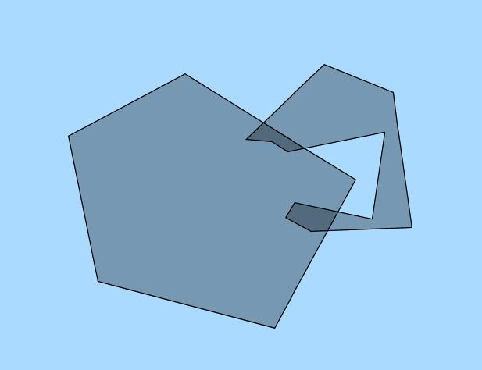
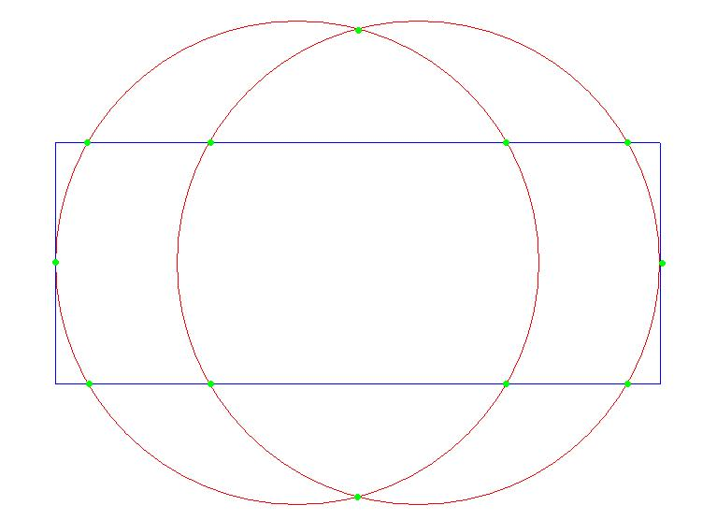
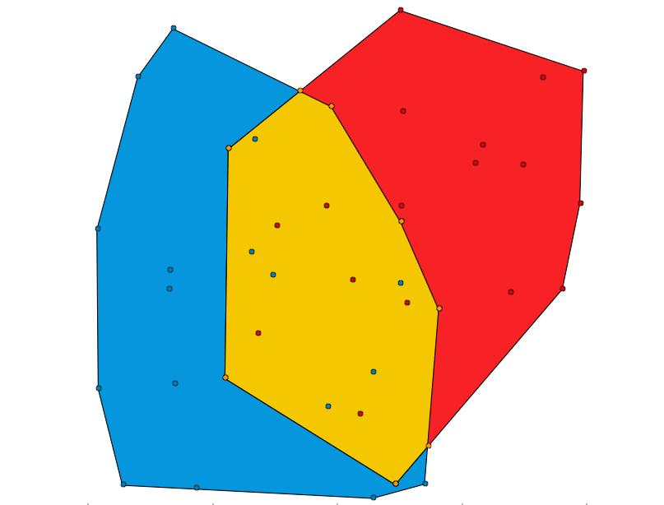
The intersection of two regions is the set of points belonging to both regions.

Multiple-Point Intersection in Graph Theory
# Source: AI Source: Provided by: [Data Path: Persons Table -> ID Column: 1, Name_En Column: Motasem Essam] -> From: [ChatGPT] on [7/25/2026]
In geometric graphs, multiple edges can cross at different points.
For example, a network of line segments may contain:
$$P_{1},P_{2},P_{3},…,P_{n}$$
as intersection points.
These points can divide edges into smaller segments.
This is useful in:
- Network analysis.
- Computational geometry.
- Road modeling.
- Circuit layouts.
- Computer graphics.

Multiple-Point Intersection in CAD
# Source: AI Source: Provided by: [Data Path: Persons Table -> ID Column: 1, Name_En Column: Motasem Essam] -> From: [ChatGPT] on [7/25/2026]
CAD software frequently calculates multiple intersections between:
- Lines.
- Arcs.
- Circles.
- Splines.
- Polygons.
- Curves.
- Surfaces.
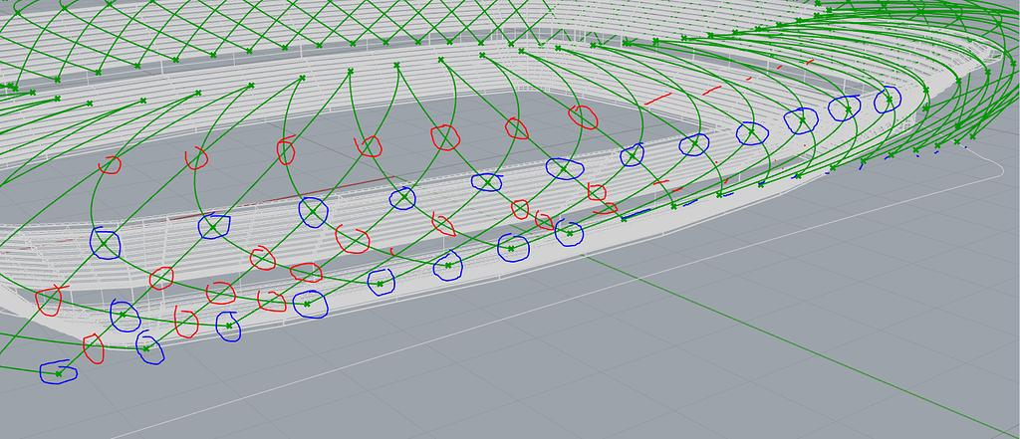
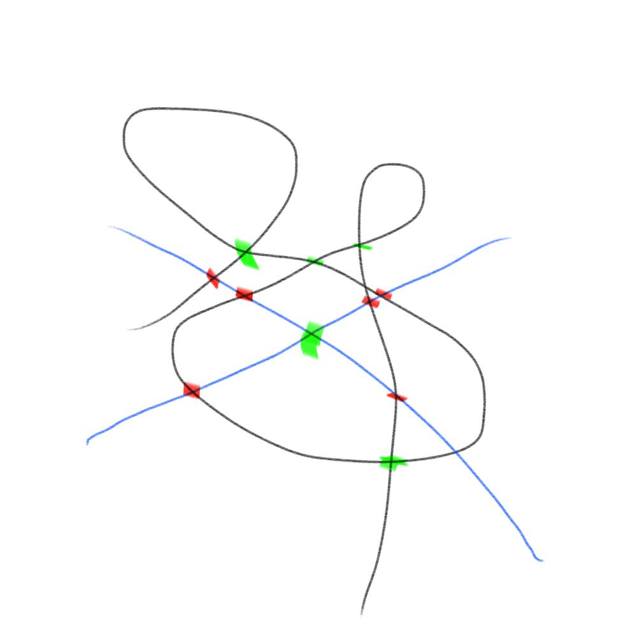
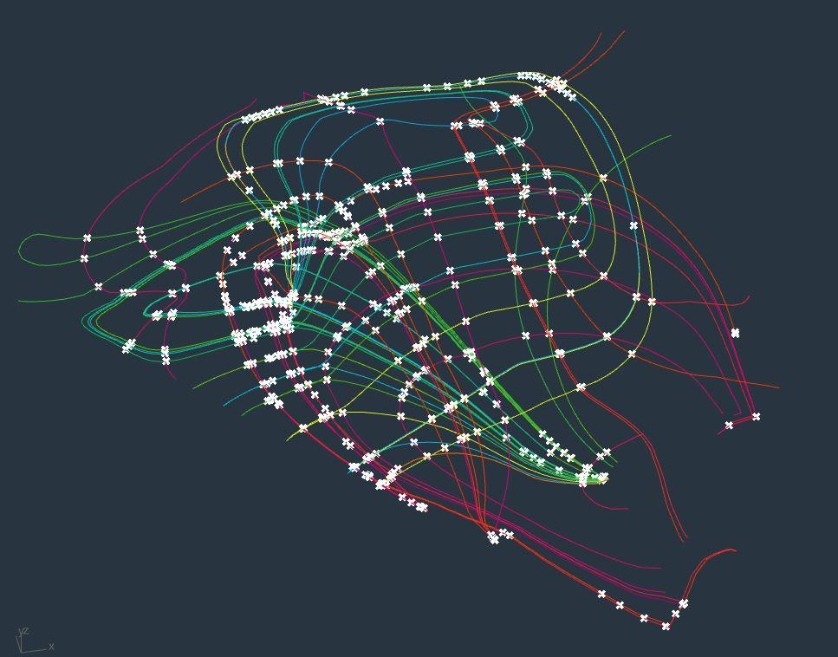
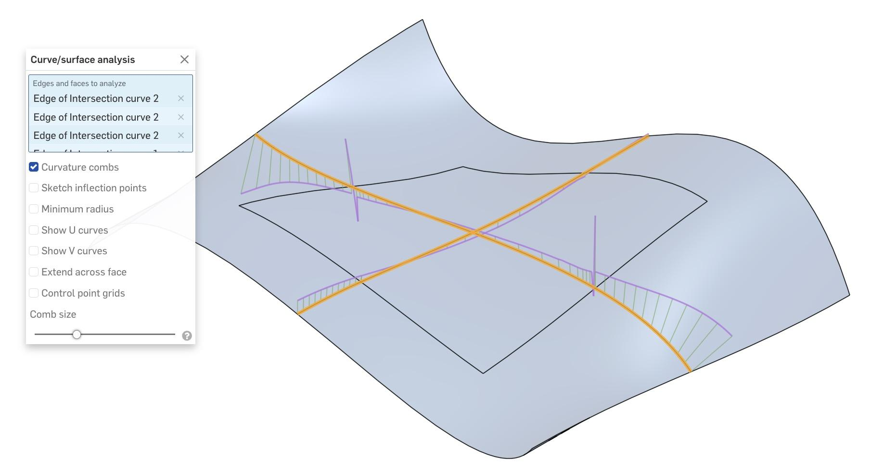
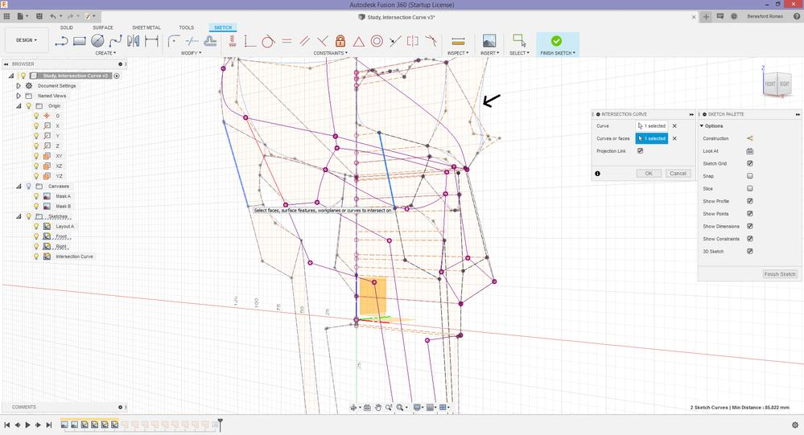
These intersection points can be used to:
- Trim objects.
- Split objects.
- Create new vertices.
- Build boundaries.
- Construct complex shapes.

Multiple-Point Intersection in Architecture
# Source: AI Source: Provided by: [Data Path: Persons Table -> ID Column: 1, Name_En Column: Motasem Essam] -> From: [ChatGPT] on [7/25/2026]
Architectural drawings can contain many intersection points.
Examples include:
- Grid lines.
- Structural beams.
- Walls.
- Roof lines.
- Floor-plan boundaries.
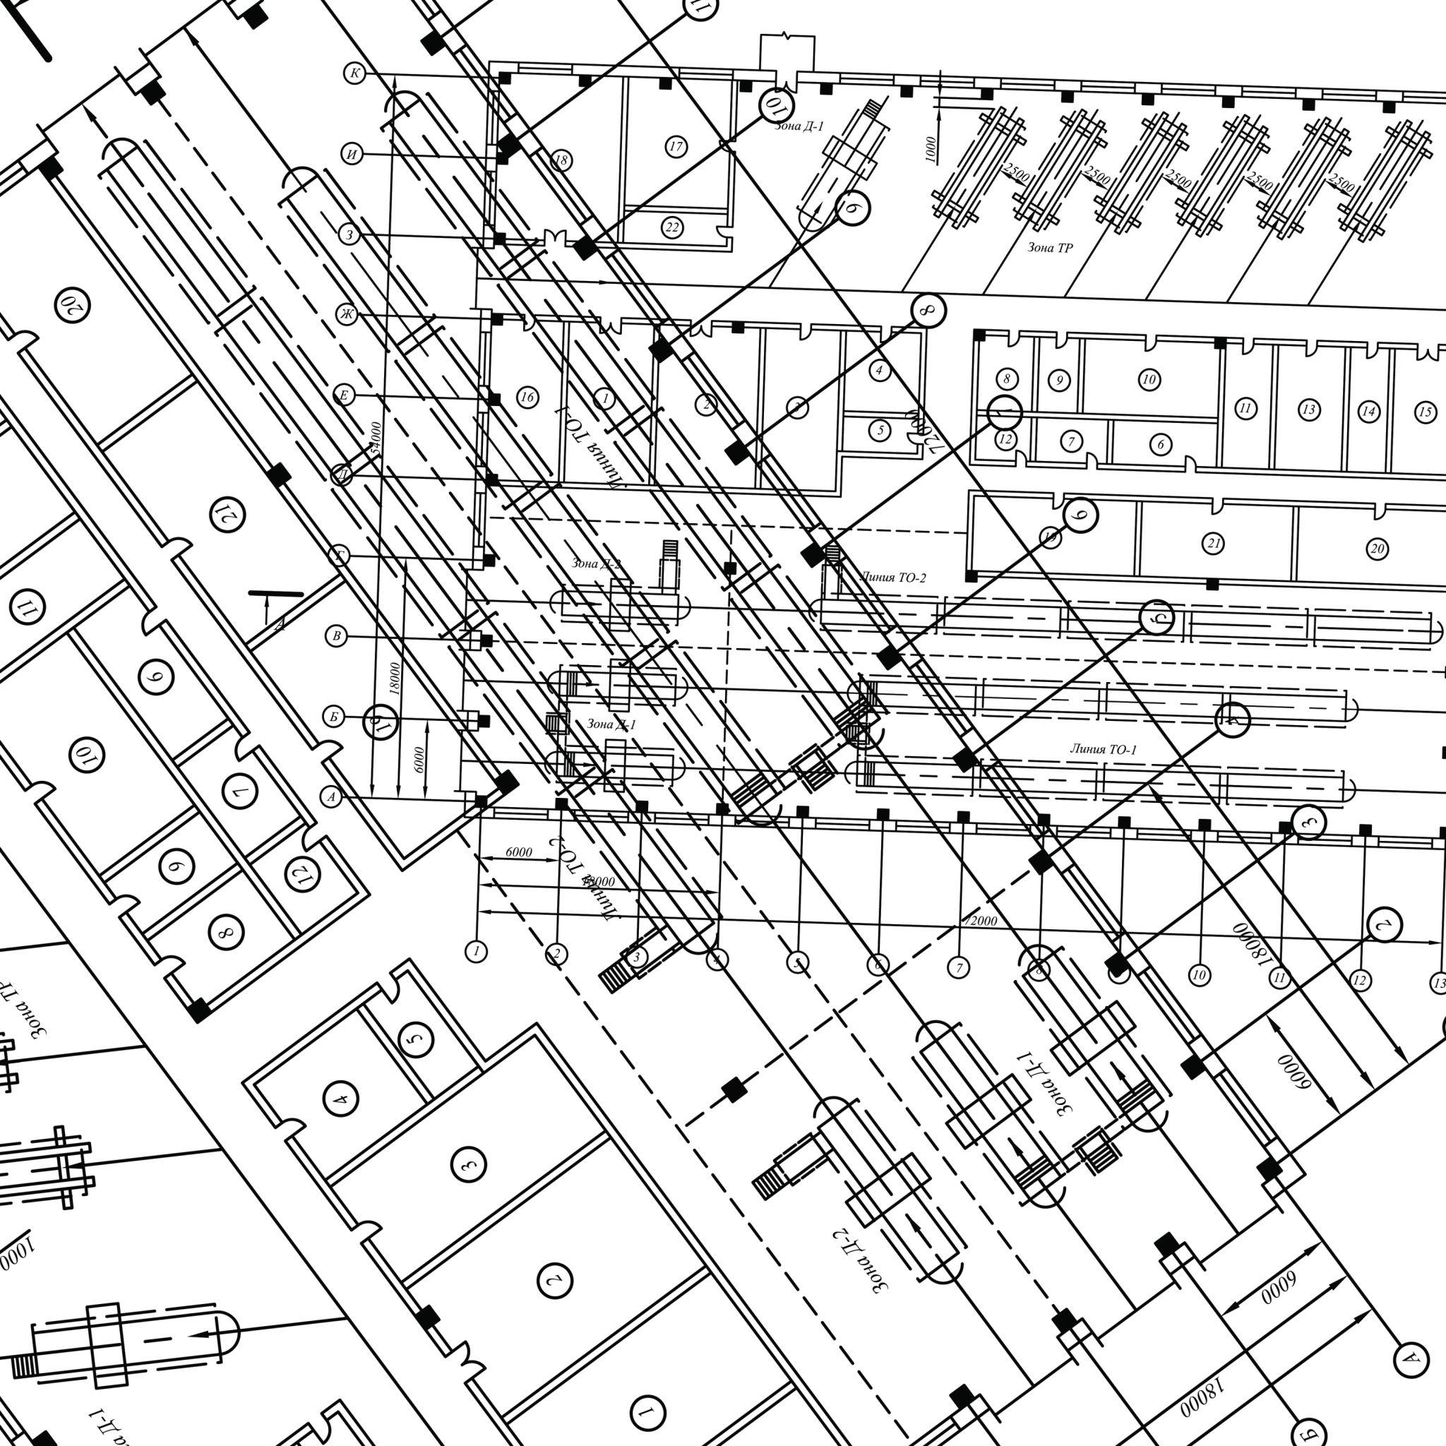
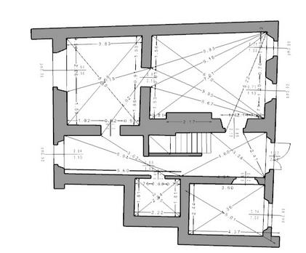
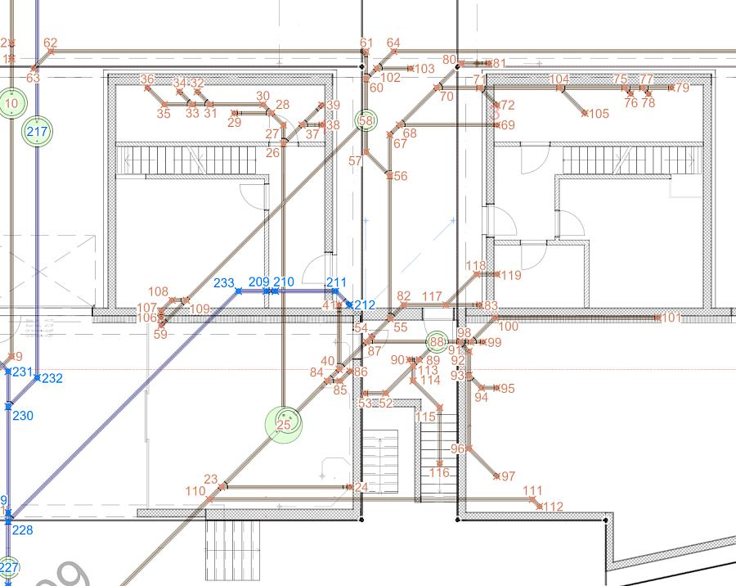
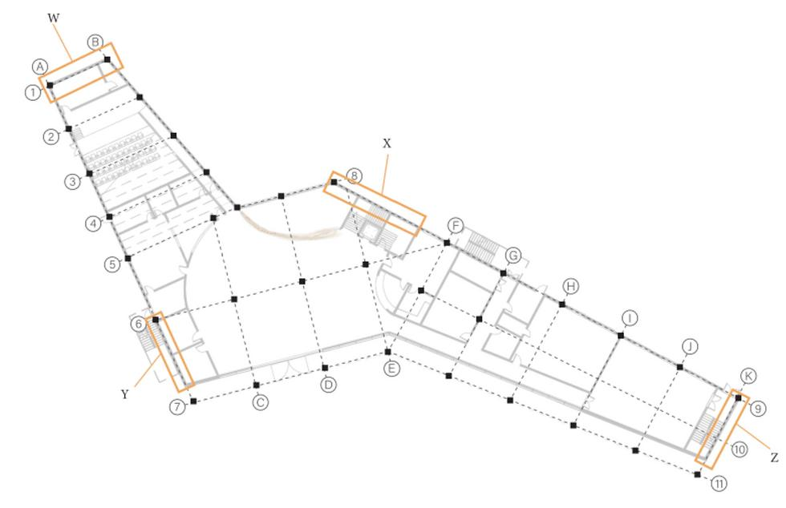
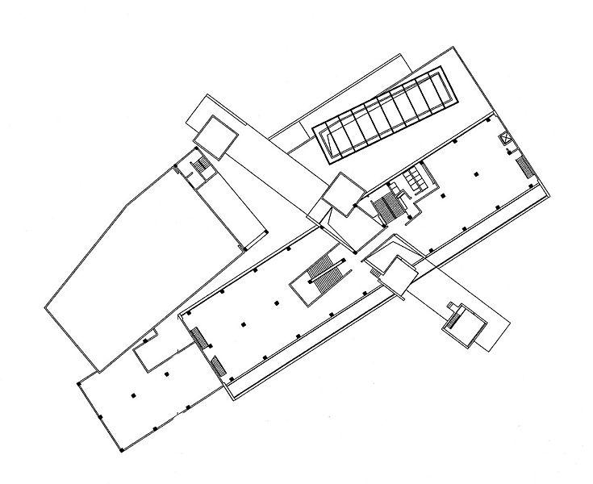

Multiple-Point Intersection in Surveying
# Source: AI Source: Provided by: [Data Path: Persons Table -> ID Column: 1, Name_En Column: Motasem Essam] -> From: [ChatGPT] on [7/25/2026]
Multiple intersections can help define boundaries and locations.
For example, survey lines may cross at several measured points to establish:
- Property boundaries.
- Road layouts.
- Geographic features.
- Survey networks.
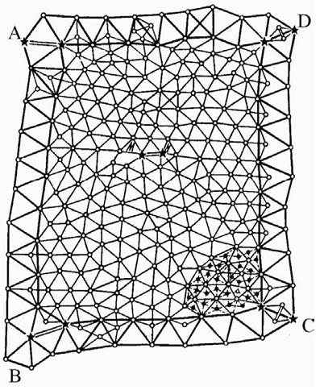
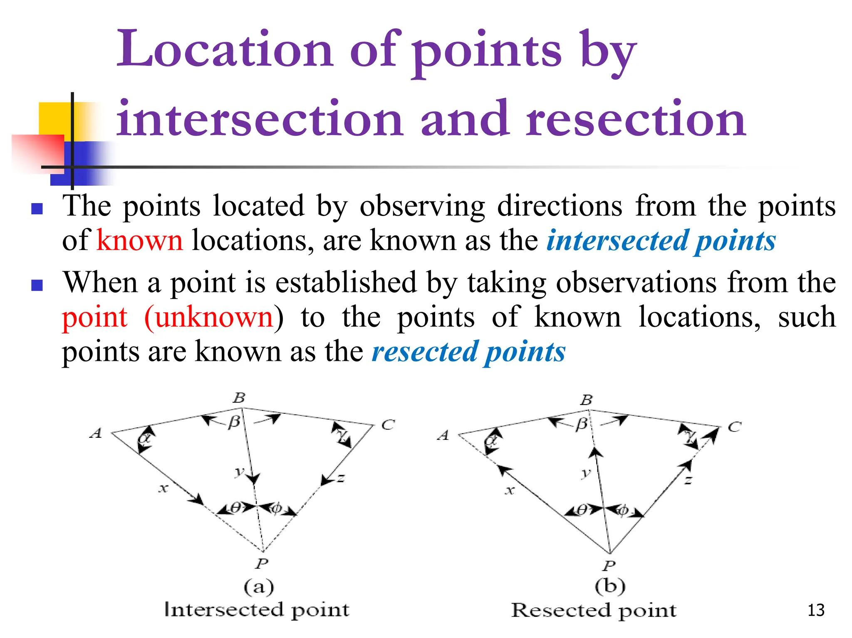
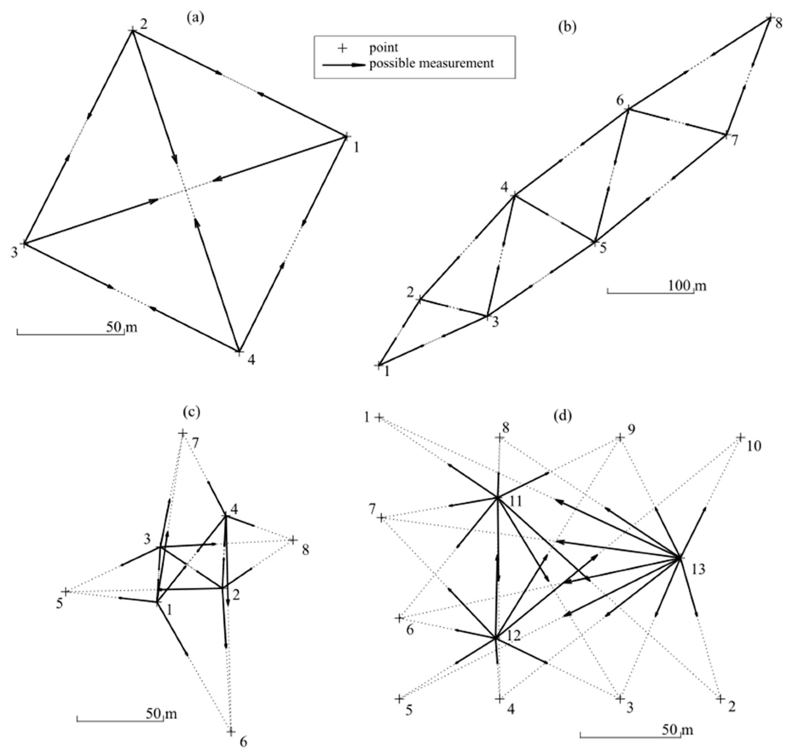
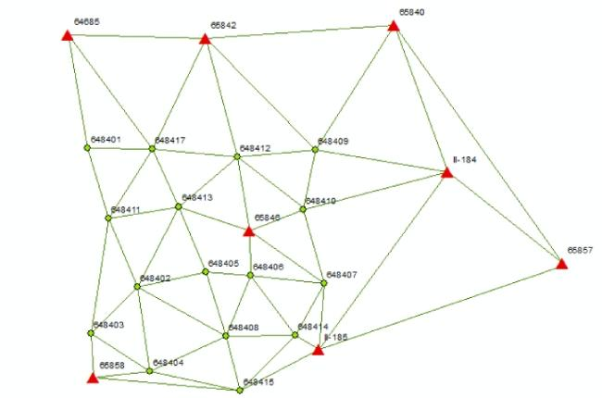
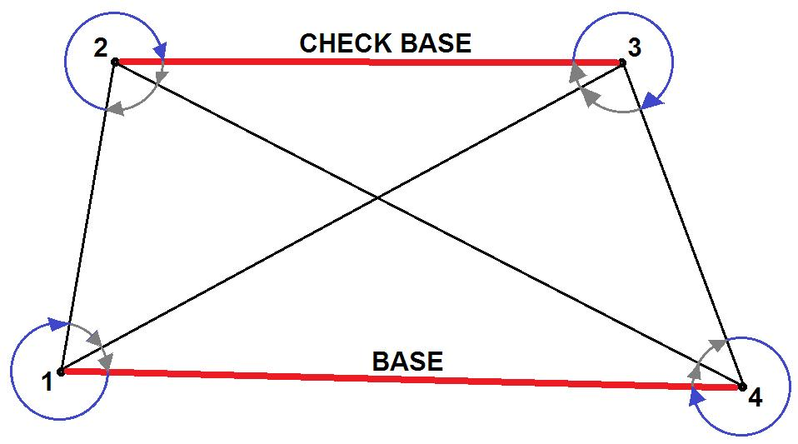

Multiple-Point Intersection in Computer Graphics
# Source: AI Source: Provided by: [Data Path: Persons Table -> ID Column: 1, Name_En Column: Motasem Essam] -> From: [ChatGPT] on [7/25/2026]
Computer graphics uses intersection calculations extensively.
Examples include:
- Ray–polygon intersections.
- Ray–surface intersections.
- Curve intersections.
- Collision detection.
- 3D modeling.
- Boolean geometry.
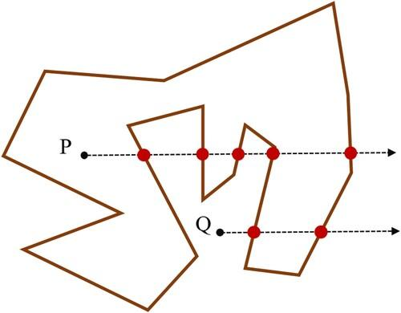
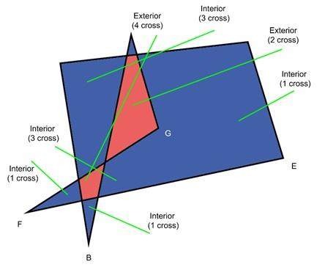
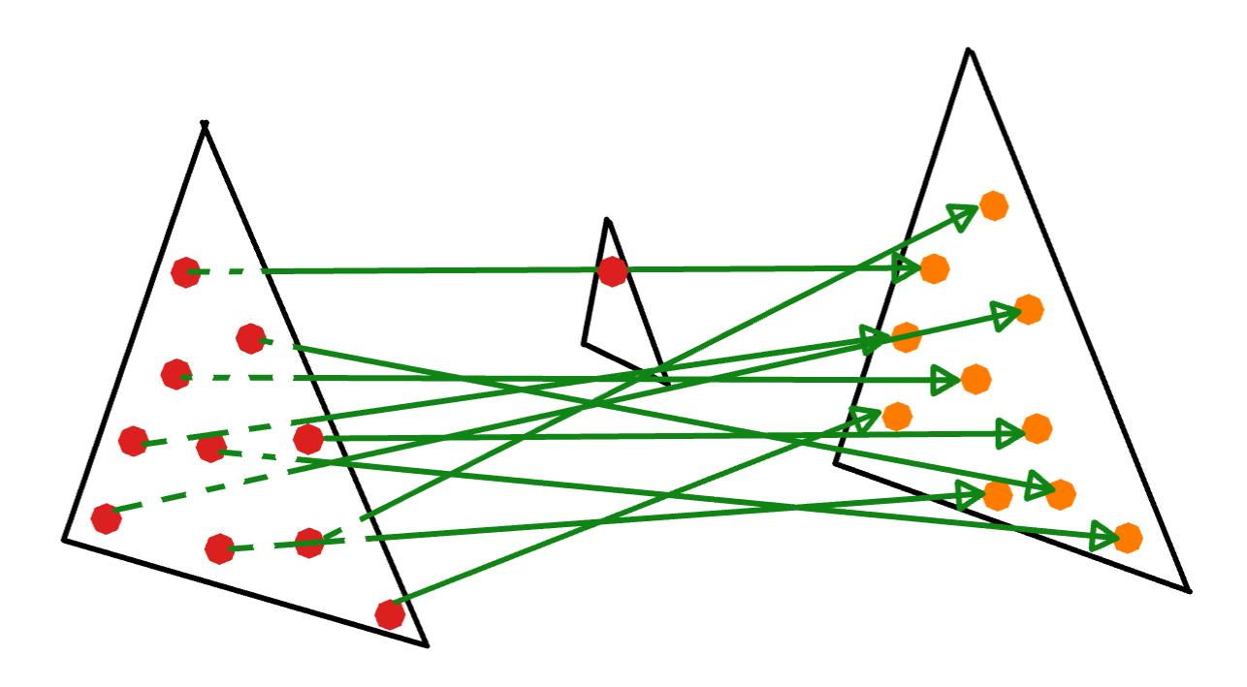
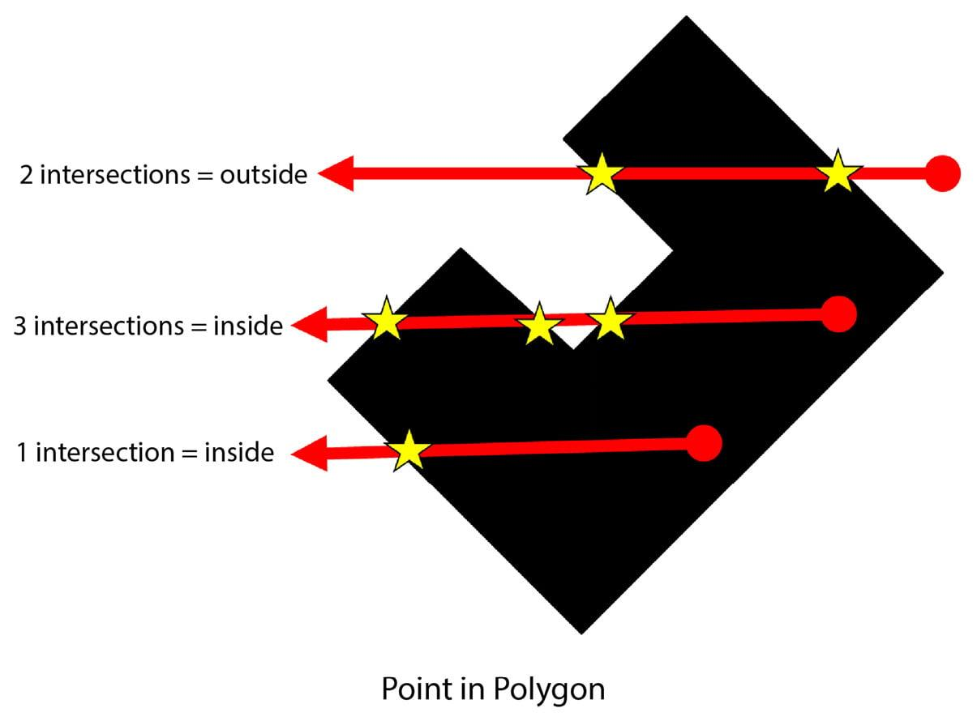
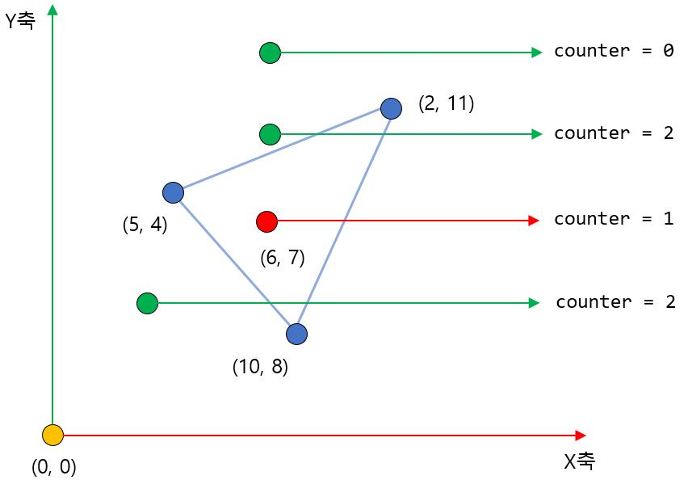

Real-World Examples
# Source: AI Source: Provided by: [Data Path: Persons Table -> ID Column: 1, Name_En Column: Motasem Essam] -> From: [ChatGPT] on [7/25/2026]
Multiple-point intersections can be represented by:
- Two roads crossing at several separate locations.
- Overlapping curved paths.
- Two circles crossing at two points.
- Multiple structural lines crossing at different locations.
- Overlapping boundaries on maps.
- Multiple paths crossing within a network.
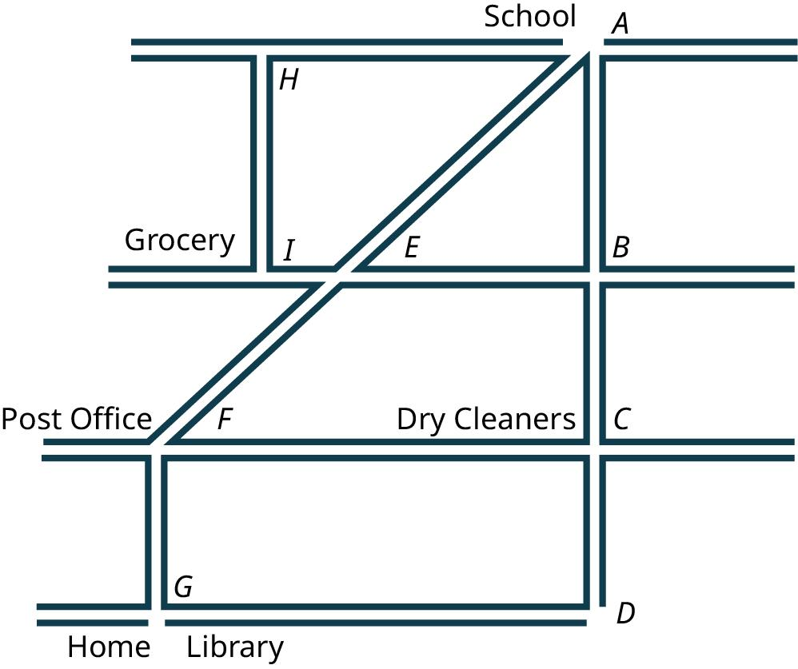
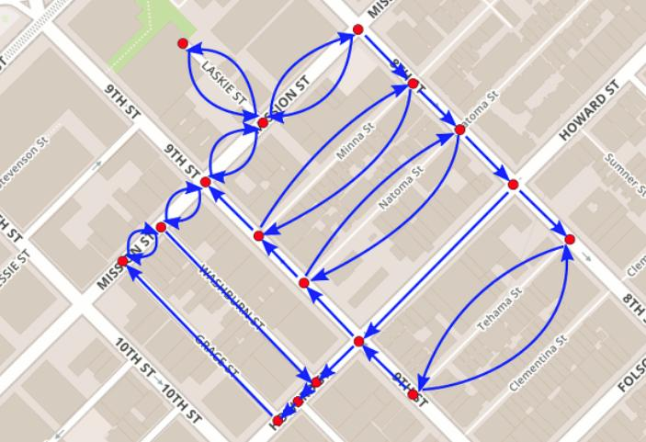
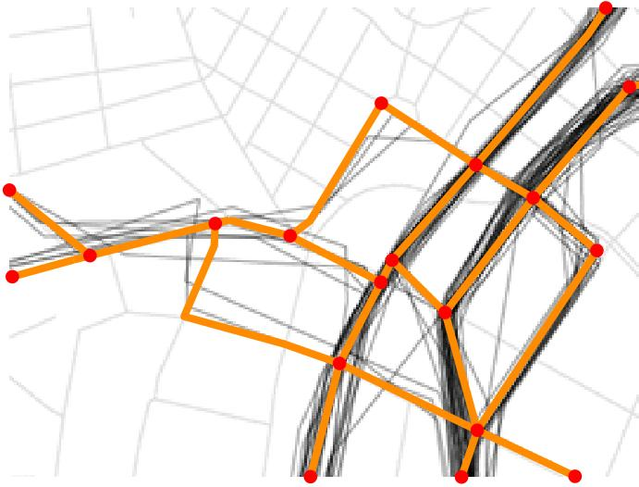
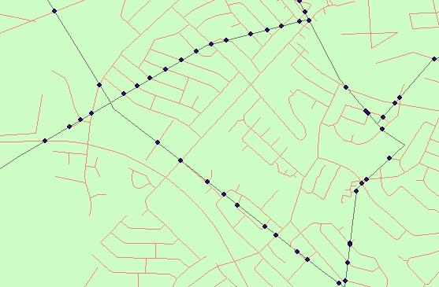
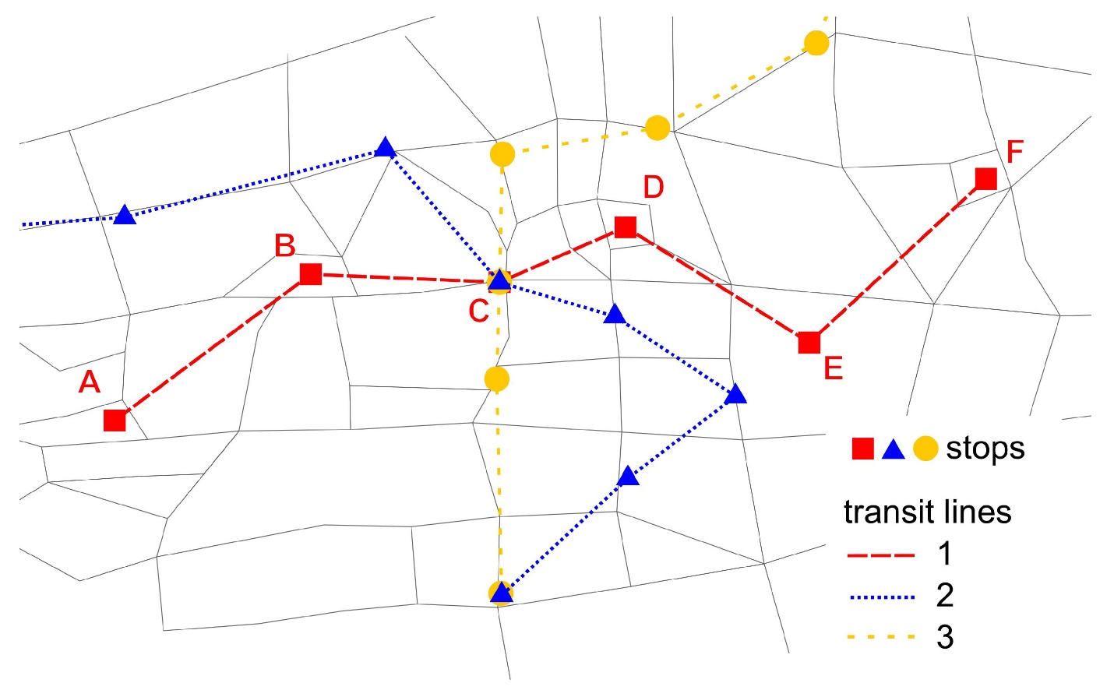

Applications
# Source: AI Source: Provided by: [Data Path: Persons Table -> ID Column: 1, Name_En Column: Motasem Essam] -> From: [ChatGPT] on [7/25/2026]
Multiple-point intersection is important in:
- Plane Geometry
- Coordinate Geometry
- Algebra
- Analytic Geometry
- Euclidean Geometry
- Computational Geometry
- Architecture
- Engineering
- Surveying
- Cartography
- CAD
- GIS
- Computer Graphics
- Robotics
- Navigation

Advantages
# Source: AI Source: Provided by: [Data Path: Persons Table -> ID Column: 1, Name_En Column: Motasem Essam] -> From: [ChatGPT] on [7/25/2026]
Studying multiple-point intersections helps to:
- Analyze complex geometric relationships.
- Find multiple solutions to geometric equations.
- Determine overlapping regions.
- Analyze curves and polygons.
- Divide shapes into smaller regions.
- Calculate intersections in CAD.
- Model networks and paths.
- Analyze structural and engineering designs.
- Support computer graphics and collision detection.

Limitations
# Source: AI Source: Provided by: [Data Path: Persons Table -> ID Column: 1, Name_En Column: Motasem Essam] -> From: [ChatGPT] on [7/25/2026]
Multiple-point intersection:
- Requires two or more distinct common points.
- Does not describe objects that meet at only one point.
- Does not describe completely coincident objects.
- Can be difficult to calculate for complex curves.
- May require algebraic or numerical methods.
- The number of intersections can become large for complex geometric objects.

Comparison with Related Intersection Types
# Source: AI Source: Provided by: [Data Path: Persons Table -> ID Column: 1, Name_En Column: Motasem Essam] -> From: [ChatGPT] on [7/25/2026]
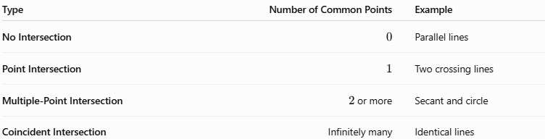
Type | Number of Common Points | Example
No Intersection | $$0$$ | Parallel lines
Point Intersection | $$1$$ | Two crossing lines
Multiple-Point Intersection | $2$ or more | Secant and circle
Coincident Intersection | Infinitely many | Identical lines
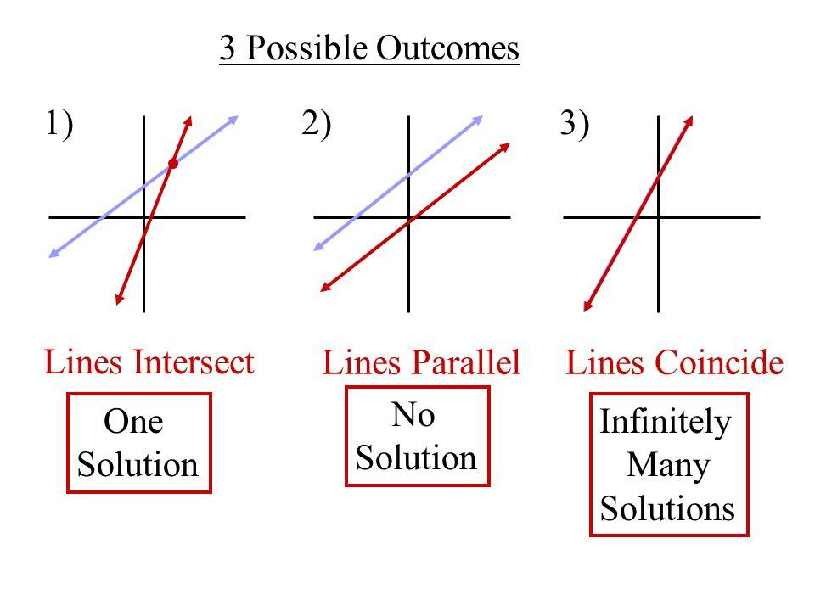
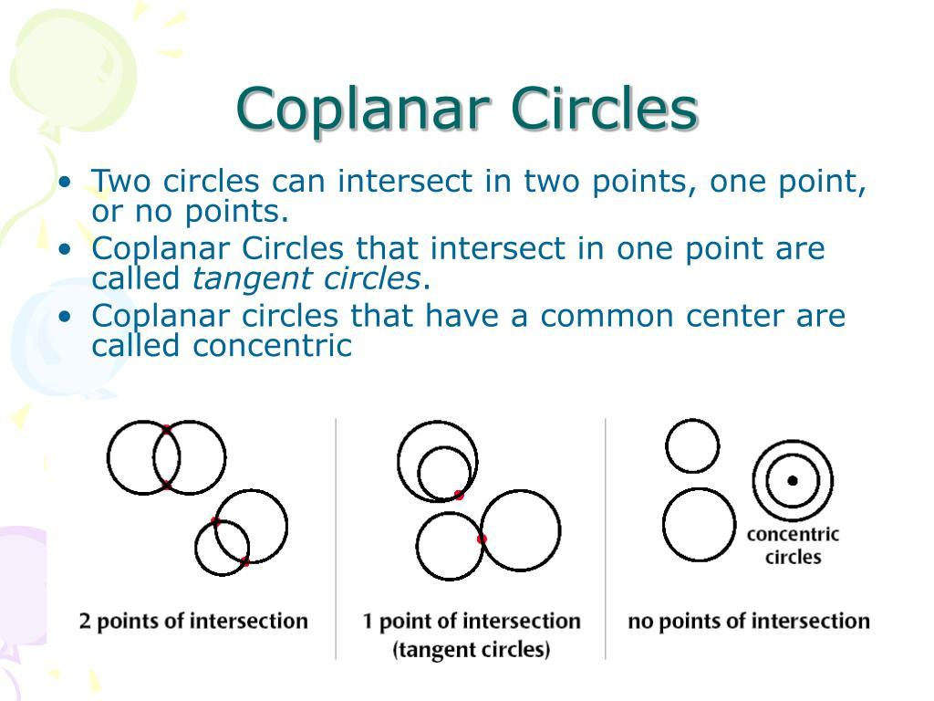

Key Points
# Source: AI Source: Provided by: [Data Path: Persons Table -> ID Column: 1, Name_En Column: Motasem Essam] -> From: [ChatGPT] on [7/25/2026]
- Multiple-Point Intersection occurs when two or more geometric objects share two or more distinct common points.
- It can be represented as:
$$\boxed{A∩B={\{P}_{1},P_{2},…,P_{n}\}}$$
where:
$$\boxed{n≥2}$$
- A line and a circle can have two intersection points.
- Two circles can intersect at two points.
- Two curves can have several intersection points.
- Multiple lines can produce many different intersection points.
- Several objects meeting at one common point is still a point intersection, not a multiple-point intersection.
- Coincident objects have infinitely many common points and are treated separately.
- In coordinate geometry, each intersection point corresponds to a solution of the relevant equations.
- Multiple-point intersections are important in geometry, algebra, CAD, GIS, engineering, surveying, and computer graphics.

Conclusion
# Source: AI Source: Provided by: [Data Path: Persons Table -> ID Column: 1, Name_En Column: Motasem Essam] -> From: [ChatGPT] on [7/25/2026]
Multiple-Point Intersection is a type of Geometric Intersection in which two or more geometric objects share two or more distinct common points. A common example is a secant line intersecting a circle at two points, represented by $l∩C={\{P}_{1},P_{2}\}$. Multiple-point intersections can also occur between circles, curves, polygons, line networks, and complex geometric objects. They are particularly important in coordinate geometry and algebra, where multiple intersection points correspond to multiple solutions, as well as in CAD, engineering, surveying, GIS, architecture, and computer graphics, where they help define boundaries, shapes, paths, and geometric relationships.

